\
Sunday, May 31, 2020
Day of Pentecost
St. Paul’s and Nativity Worship Together

The Rev. Christopher Martin
The Rev. Kirsten Snow Spalding
The Rev. Scott Gambrill Sinclair

The Word of God Led by the Rev. Christopher Martin

Prelude “Song of the Pilgrim” Mendelssohn
“Rondo-Allegro Commodo” op 14 # 1 Beethoven
Performed by Nativity Music Director, Dylan Snodgrass

Entrance Rite

Entrance Hymn Come, Holy Spirit, heavenly Dove (Saint Agnes) (H 510)
Opening Acclamation (BCP p. 355)
The people standing, the Officiant says
Officiant | Alleluia. Christ is risen.
People | The Lord is risen indeed. Alleluia.

Collect for Purity (BCP p. 355)
The Officiant may say
Almighty God, to you all hearts are open, all desires known, and from you no secrets are hid: Cleanse the thoughts of our hearts by the inspiration of your Holy Spirit, that we may perfectly love you, and worthily magnify your holy Name; through Christ our Lord. Amen.

Opening Anthem or Song of Praise S 277 Glory to God (Canticle 20) (Hurd) (BCP p. 356)
The following is sung, all standing

The Collect of the Day (BCP p. 357)
Officiant | The Lord be with you.
People | And also with you.
Officiant | Let us pray.

O God, who on this day taught the hearts of your faithful people by sending to them the light of your Holy Spirit: Grant us by the same Spirit to have a right judgment in all things, and evermore to rejoice in his holy comfort; through Jesus Christ your Son our Lord, who lives and reigns with you, in the unity of the Holy Spirit, one God, for ever and ever. Amen.

The Lessons

First Reading: Acts 2:1-21 Judy Rowcliffe, Lector
The people sit.
A Reading from the Acts of the Apostles.
¹When the day of Pentecost had come, they were all together in one place. ²And suddenly from heaven there came a sound like the rush of a violent wind, and it filled the entire house where they were sitting. ³Divided tongues, as of fire, appeared among them, and a tongue rested on each of them. ⁴All of them were filled with the Holy Spirit and began to speak in other languages, as the Spirit gave them ability.
⁵Now there were devout Jews from every nation under heaven living in Jerusalem. ⁶And at this sound the crowd gathered and was bewildered, because each one heard them speaking in the native language of each. ⁷Amazed and astonished, they asked, “Are not all these who are speaking Galileans? ⁸And how is it that we hear, each of us, in our own native language? ⁹Parthians, Medes, Elamites, and residents of Mesopotamia, Judea and Cappadocia, Pontus and Asia, ¹⁰Phrygia and Pamphylia, Egypt and the parts of Libya belonging to Cyrene, and visitors from Rome, both Jews and proselytes, ¹¹Cretans and Arabs—in our own languages we hear them speaking about God’s deeds of power.” ¹²All were amazed and perplexed, saying to one another, “What does this mean?” ¹³But others sneered and said, “They are filled with new wine.”
¹⁴But Peter, standing with the eleven, raised his voice and addressed them, “Men of Judea and all who live in Jerusalem, let this be known to you, and listen to what I say. ¹⁵Indeed, these are not drunk, as you suppose, for it is only nine o’clock in the morning. ¹⁶No, this is what was spoken through the prophet Joel:
¹⁷‘In the last days it will be, God declares,
that I will pour out my Spirit upon all flesh,
and your sons and your daughters shall prophesy,
and your young men shall see visions,
and your old men shall dream dreams.
¹⁸Even upon my slaves, both men and women,
in those days I will pour out my Spirit;
and they shall prophesy.
¹⁹And I will show portents in the heaven above
and signs on the earth below,
blood, and fire, and smoky mist.
²⁰The sun shall be turned to darkness
and the moon to blood,
before the coming of the Lord’s great and glorious day.
²¹Then everyone who calls on the name of the Lord shall be saved.’ ”

Reader | The Word of the Lord.
People | Thanks be to God.

Silence may follow.

Psalm: Psalm 104:25-35, 37
Remain seated.
²⁵O Lord, how manifold are your works! *
In wisdom you have made them all;
the earth is full of your creatures.
²⁶Yonder is the great and wide sea
with its living things too many to number, *
creatures both small and great.
²⁷There move the ships,
and there is that Leviathan, *
which you have made for the sport of it.
²⁸All of them look to you *
to give them their food in due season.
²⁹You give it to them; they gather it; *
you open your hand, and they are filled with good things.
³⁰You hide your face, and they are terrified; *
you take away their breath,
and they die and return to their dust.
³¹You send forth your Spirit, and they are created; *
and so you renew the face of the earth.
³²May the glory of the Lord endure forever; *
may the Lord rejoice in all his works.
³³He looks at the earth and it trembles; *
he touches the mountains and they smoke.
³⁴I will sing to the Lord as long as I live; *
I will praise my God while I have my being.
³⁵May these words of mine please him; *
I will rejoice in the Lord.
³⁷Bless the Lord, O my soul. *
Hallelujah!

Second Reading: 1 Corinthians 12:3b-13 Judy Rowcliffe, Lector
The people sit.
A Reading from Paul's First letter to the Church in Corinth.
^{3b}No one can say “Jesus is Lord” except by the Holy Spirit.
⁴Now there are varieties of gifts, but the same Spirit; ⁵and there are varieties of services, but the same Lord; ⁶and there are varieties of activities, but it is the same God who activates all of them in everyone. ⁷To each is given the manifestation of the Spirit for the common good. ⁸To one is given through the Spirit the utterance of wisdom, and to another the utterance of knowledge according to the same Spirit, ⁹to another faith by the same Spirit, to another gifts of healing by the one Spirit, ¹⁰to another the working of miracles, to another prophecy, to another the discernment of spirits, to another various kinds of tongues, to another the interpretation of tongues. ¹¹All these are activated by one and the same Spirit, who allots to each one individually just as the Spirit chooses.
¹²For just as the body is one and has many members, and all the members of the body, though many, are one body, so it is with Christ. ¹³For in the one Spirit we were all baptized into one body—Jews or Greeks, slaves or free—and we were all made to drink of one Spirit.

Reader | The Word of the Lord.
People | Thanks be to God.

Silence may follow.
Gospel Allelluia Dylan Snodgrass, Composer
Gospel: John 20:19-23 The Rev. Scott Sinclair
All stand.
Deacon | The Holy Gospel of our Lord Jesus Christ according to John.
People | Glory to you, Lord Christ.

¹⁹When it was evening on that day, the first day of the week, and the doors of the house where the disciples had met were locked for fear of the Jews, Jesus came and stood among them and said, “Peace be with you.” ²⁰After he said this, he showed them his hands and his side. Then the disciples rejoiced when they saw the Lord. ²¹Jesus said to them again, “Peace be with you. As the Father has sent me, so I send you.” ²²When he had said this, he breathed on them and said to them, “Receive the Holy Spirit. ²³If you forgive the sins of any, they are forgiven them; if you retain the sins of any, they are retained.”

Deacon | The Gospel of the Lord.
People | Praise to you, Lord Christ.

The Sermon The Rev. Kirsten Snow Spalding
The people stand as they are able.
THE BAPTISMAL COVENANT Led by The Rev. Christopher Martin
Priest Do you believe in God the Father?
People I believe in God, the Father almighty, creator of heaven and earth.
Priest Do you believe in Jesus Christ, the Son of God?
People I believe in Jesus Christ, his only Son, our Lord.
He was conceived by the power of the Holy Spirit and born of the Virgin Mary.
He suffered under Pontius Pilate, was crucified, died, and was buried.
He descended to the dead.
On the third day he rose again.
He ascended into heaven, and is seated at the right hand of the Father.
He will come again to judge the living and the dead.
Priest Do you believe in God the Holy Spirit?
People I believe in the Holy Spirit,
the holy catholic Church,
the communion of saints,
the forgiveness of sins,
the resurrection of the body,
and the life everlasting.
Priest Will you continue in the apostles' teaching and fellowship, in the breaking of bread, and in the prayers?
People I will, with God's help.
Priest Will you persevere in resisting evil, and, whenever you fall into sin, repent and return to the Lord?
People I will, with God's help.
Priest Will you proclaim by word and example the Good News of God in Christ?
People I will, with God's help.
Priest Will you seek and serve Christ in all persons, loving your neighbor as yourself?
People I will, with God's help.

Priest Will you strive for justice and peace among all people, and respect the dignity of every human being?

People I will, with God's help.
The Prayers of the People
All remain standing.
Let us pray for the Church and for the world.
Grant, Almighty God, that all who confess your Name may be united in your truth, live together in your love, and reveal your glory in the world.
Silence
Lord, in your mercy
Hear our prayer.
Guide the people of this land, and of all the nations, in the ways of justice and peace; that we may honor one another and serve the common good.
Silence
Lord, in your mercy
Hear our prayer.
Give us all a reverence for the earth as your own creation, that we may use its resources rightly in the service of others and to your honor and glory.
Silence
Lord, in your mercy
Hear our prayer.
Bless all whose lives are closely linked with ours, and grant that we may serve Christ in them, and love one another as he loves us.
Silence
Lord, in your mercy
Hear our prayer.
Comfort and heal all those who suffer in body, mind, or spirit; give them courage and hope in their troubles, and bring them the joy of your salvation.
Silence
Lord, in your mercy
Hear our prayer.
We commend to your mercy all who have died, that your will for them may be fulfilled; and we pray that we may share with all your saints in your eternal kingdom.
Silence
Lord, in your mercy
Hear our prayer.
The Officiant adds a concluding Collect.

The Peace (BCP p. 360)
All stand.
Officiant | The peace of the Lord be always with you.
People | And also with you.

Then the Ministers and the People may greet one another in the name of the Lord.

Announcements

After the Pentecost service, we’ll have a combined Zoom coffee hour. The link is here:
Join Zoom Meeting https://us02web.zoom.us/j/81508477630
Meeting ID: 815 0847 7630
One tap mobile +14086380968,,81508477630# US (San Jose)
+16699006833,,81508477630# US (San Jose)
Find your local number: https://us02web.zoom.us/u/keqb8LjKyt

Great Commandment small groups for discussion and prayer will kick off during the week of June 7th. You can sign up using this link.

We will with thanksgiving receive offerings of Nativity and St. Paul’s pledges and plate today. You can contribute by sending a check to the church or by using the “Give” button on our website, www.nativityonthehill.org or on St. Paul’s website, https://stpaulssanrafael.org/giving/

All who participate in this Holy Eucharist virtually receive the full benefits of the sacrament by coming with the intention of being united with Christ and one another. (BCP 457)

The Holy Communion The Rev. Kirsten Snow Spalding, Presiding

Offertory Sentence (BCP p. 376)
The Officiant says
Offer to God a sacrifice of thanksgiving, and make good your vows to the Most High. Psalm 50:14

Offertory Hymn Lo, in the likeness of fire, on those who await his appearing (Salve festa dies) (H 225)

The Great Thanksgiving

Sursum Corda (BCP p. 361)
The People remain standing.
Officiant | The Lord be with you.
People | And also with you.
Officiant | Lift up your hearts.
People | We lift them to the Lord.
Officiant | Let us give thanks to the Lord our God.
People | It is right to give him thanks and praise.

Proper Preface (BCP p. 361)
Facing the Holy Table, the Officiant proceeds
It is right, and a good and joyful thing, always and everywhere to give thanks to you, Father Almighty, Creator of heaven and earth.
Through Jesus Christ our Lord. In fulfillment of his true promise, the Holy Spirit came down [on this day] from heaven, lighting upon the disciples, to teach them and to lead them into all truth; uniting peoples of many tongues in the confession of one faith, and giving to your Church the power to serve you as a royal priesthood, and to preach the Gospel to all nations.
Therefore we praise you, joining our voices with Angels and Archangels and with all the company of heaven, who for ever sing this hymn to proclaim the glory of your Name:

Sanctus
Officiant and People

Words of Institution (BCP p. 362)
The People stand or kneel.
The Officiant continues
Holy and gracious Father: In your infinite love you made us for yourself; and, when we had fallen into sin and become subject to evil and death, you, in your mercy, sent Jesus Christ, your only and eternal Son, to share our human nature, to live and die as one of us, to reconcile us to you, the God and Father of all.
He stretched out his arms upon the cross, and offered himself in obedience to your will, a perfect sacrifice for the whole world.
On the night he was handed over to suffering and death, our Lord Jesus Christ took bread; and when he had given thanks to you, he broke it, and gave it to his disciples, and said, “Take, eat: This is my Body, which is given for you. Do this for the remembrance of me.”
After supper he took the cup of wine; and when he had given thanks, he gave it to them, and said, “Drink this, all of you: This is my Blood of the new Covenant, which is shed for you and for many for the forgiveness of sins. Whenever you drink it, do this for the remembrance of me.”
Therefore we proclaim the mystery of faith:
Officiant and People
Christ has died.
Christ is risen.
Christ will come again.

Epiclesis (BCP p. 363)
The Officiant continues
We celebrate the memorial of our redemption, O Father, in this sacrifice of praise and thanksgiving. Recalling his death, resurrection, and ascension, we offer you these gifts.
Sanctify them by your Holy Spirit to be for your people the Body and Blood of your Son, the holy food and drink of new and unending life in him. Sanctify us also that we may faithfully receive this holy Sacrament, and serve you in unity, constancy, and peace; and at the last day bring us with all your saints into the joy of your eternal kingdom.
All this we ask through your Son Jesus Christ. By him, and with him, and in him, in the unity of the Holy Spirit all honor and glory is yours, Almighty Father, now and for ever. AMEN.

The Lord’s Prayer (BCP p. 363)
As our Savior Christ has taught us, we now pray,
People and Officiant
Our Father in heaven,
hallowed be your Name,
your kingdom come,
your will be done, on earth as in heaven.
Give us today our daily bread.
Forgive us our sins
as we forgive those who sin against us.
Save us from the time of trial
and deliver us from evil.
For the kingdom, the power,
and the glory are yours,
now and forever. Amen.

The Breaking of the Bread

Fraction Anthem S 151 Christ our Passover (Hurd) (BCP p. 364)

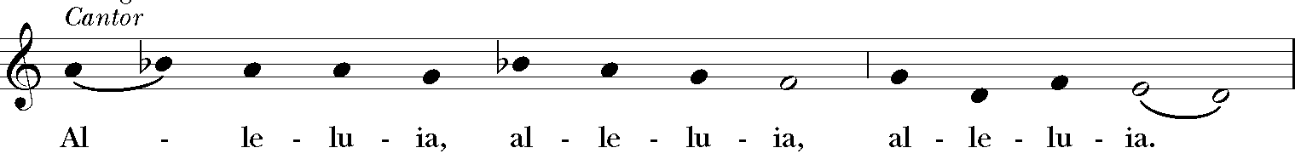
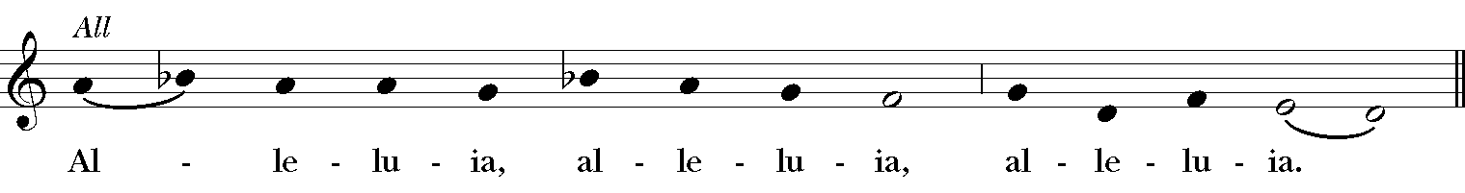
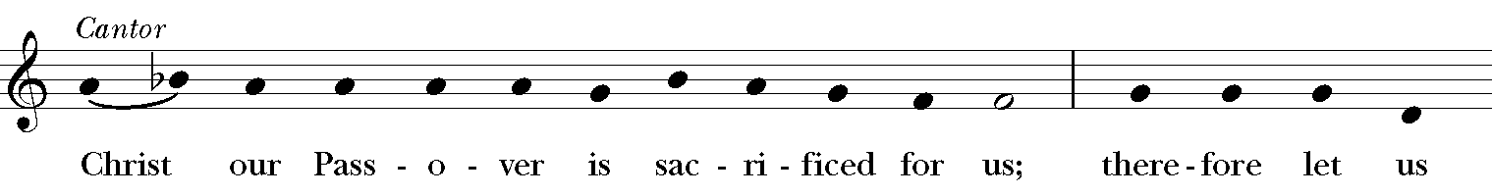
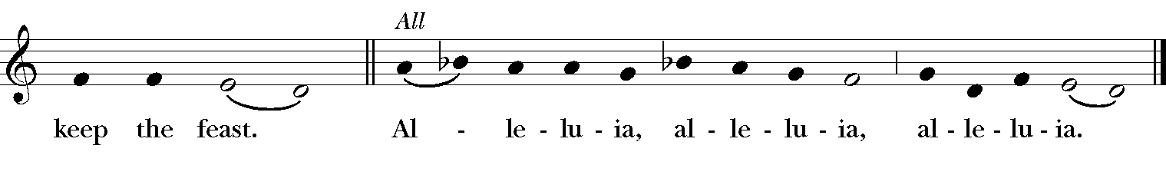

Invitation (BCP p. 364)
The Officiant says
The Gifts of God for the People of God.

Distribution (BCP p. 365)
The minister takes the Sacrament in both kinds
The Body of Christ, the bread of heaven.
The Blood of Christ, the cup of salvation. [Amen.]

POST COMMUNION PRAYER
After Communion, the Officiant says
Let us pray.
Officiant and People
Eternal God, heavenly Father,
you have graciously accepted us as living members
of your Son our Savior Jesus Christ,
and you have fed us with spiritual food
in the Sacrament of his Body and Blood.
Send us now into the world in peace,
and grant us strength and courage
to love and serve you
with gladness and singleness of heart;
through Christ our Lord. Amen.

Blessing (BCP p. 366)
The Priest blesses the people, saying
Holy eternal Majesty,
Holy incarnate Word,
Holy abiding Spirit,
Bless you for evermore. Amen.

Post-Communion Hymn There's a sweet, sweet Spirit in this place (WLP 752)
Dismissal (BCP p. 366)

 | Let us go forth in the name of Christ. Alleluia, alleluia.
People | Thanks be to God. Alleluia, alleluia.

POSTLUDE Prelude in G Minor Rachmaninov
Performed by Dylan Snodgrass, Nativity Music Director

From riteplanning.com.
Copyright © 2020 Church Publishing Inc. All rights reserved.

