The Burial of the Dead
September 6, 2020, 1 p.m.

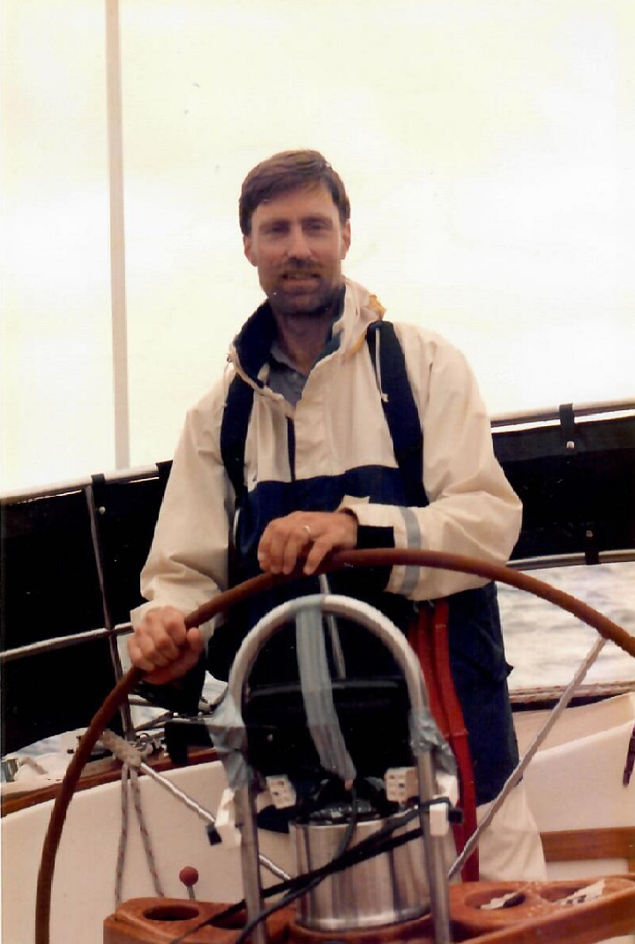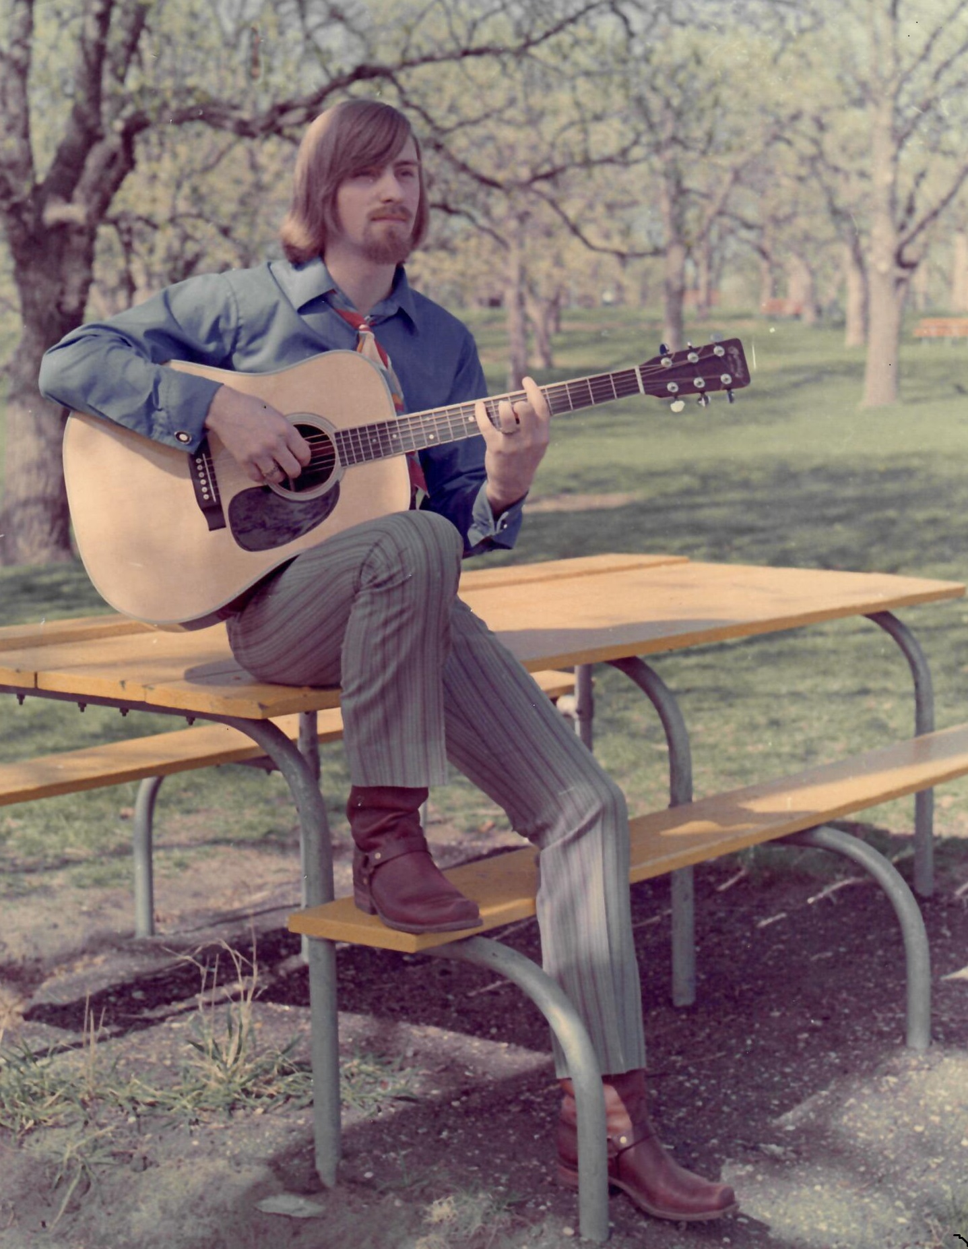
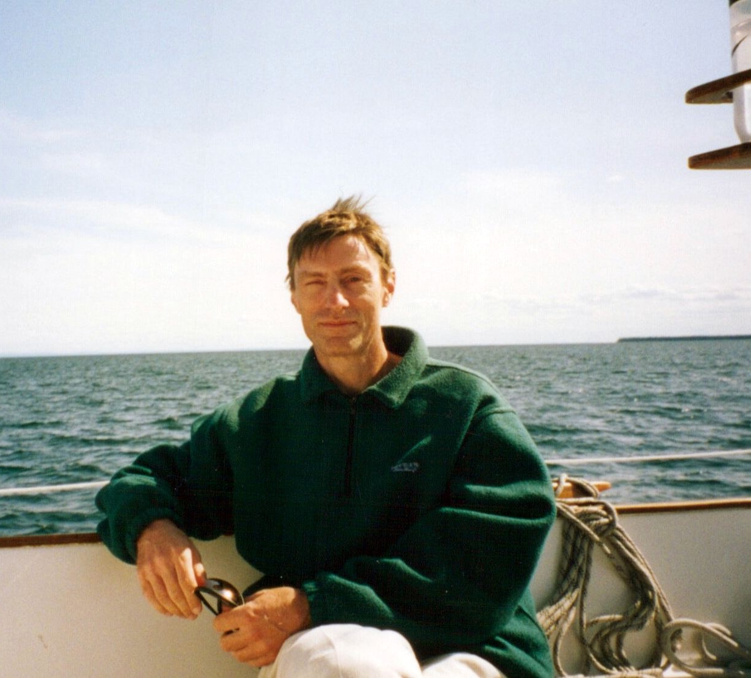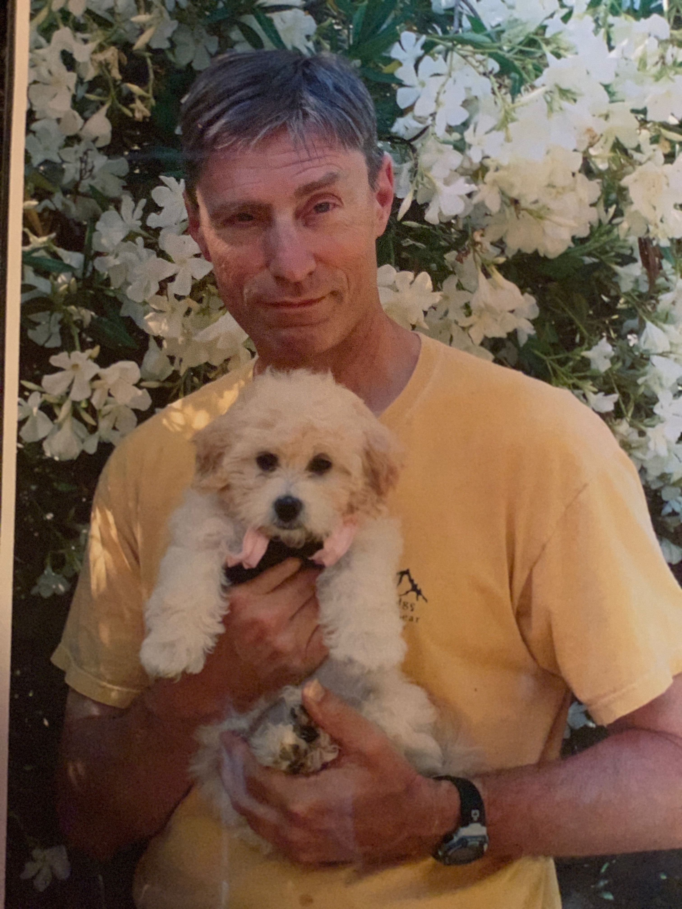

Phillip Sandahl

March 3, 1948- April 21, 2020

The Episcopal Church of the Nativity
The Rev. Kirsten Snow Spalding, Rector
The Rev. Scott Sinclair, Assisting Priest
The Rev. Rebecca Morehouse, Deacon

A WITNESS
A witness is a man who stands out
Because he is not afraid to stand up.
A man who outreaches others
Because he reaches out to others.
A man who lifts others up
Because he bends down to their weakness.
A man whose heart has grown great
Because ·he has learned to become small.
A witness is all this and more.

He is a man who walks across the waste lands

of human lives and uncovers hidden springs.

A man who opens windows everywhere to the sunlight

and springtime fragrance of the Risen Christ.
And passing through the door of self-filled hearts
He lights and leaves behind an everlasting flame.
Ultimately a witness is a man who does all these things
Because he is not afraid to love.
Andrew Au, CP

Music for Contemplation I Want to Follow Jesus. Performed by Phillip Sandahl.
Presider
I am Resurrection and I am Life, says the Lord.
Whoever has faith in me shall have life,
even though he die.
And everyone who has life,
and has committed himself to me in faith,
shall not die for ever.
As for me, I know that my Redeemer lives
and that at the last he will stand upon the earth.
After my awaking, he will raise me up;
and in my body I shall see God.
I myself shall see, and my eyes behold him
who is my friend and not a stranger.
For none of us has life in himself,
and none becomes his own master when he dies.
For if we have life, we are alive in the Lord,
and if we die, we die in the Lord.
So, then, whether we live or die,
we are the Lord's possession.
Happy from now on
are those who die in the Lord!
So it is, says the Spirit,
for they rest from their labors.
When all are in place, the Presider addresses the congregation,
acknowledging the purpose of the gathering, and bidding their
prayers for the deceased and the bereaved.
The Presider then says
The Lord be with you
People And also with you.
Celebrant Let us pray.
Silence may be kept; after which the Presider says the following
Collects
O God, who by the glorious resurrection of your Son Jesus
Christ destroyed death, and brought life and immortality to
light: Grant that your servant Phillip Sandahl being raised with him, may
know the strength of his presence, and rejoice in his eternal
glory; who with you and the Holy Spirit lives and reigns, one
God, for ever and ever. Amen.
Presider
Most merciful God, whose wisdom is beyond our
understanding: Deal graciously with Phillip’s family and friends in their grief.
Surround them with your love, that they may not be
overwhelmed by their loss, but have confidence in your
goodness, and strength to meet the days to come; through
Jesus Christ our Lord. Amen.
First Reading from Isaiah, Chapter 6, verses 1-8. Read by Thomas Junnila

6 In the year that King Uzziah died, I saw the Lord sitting on a throne, high and lofty; and the hem of his robe filled the temple. ² Seraphs were in attendance above him; each had six wings: with two they covered their faces, and with two they covered their feet, and with two they flew. ³ And one called to another and said:
“Holy, holy, holy is the Lord of hosts;
the whole earth is full of his glory.”
⁴ The pivots on the thresholds shook at the voices of those who called, and the house filled with smoke. ⁵ And I said: “Woe is me! I am lost, for I am a man of unclean lips, and I live among a people of unclean lips; yet my eyes have seen the King, the Lord of hosts!”
⁶ Then one of the seraphs flew to me, holding a live coal that had been taken from the altar with a pair of tongs. ⁷ The seraph touched my mouth with it and said: “Now that this has touched your lips, your guilt has departed and your sin is blotted out.” ⁸ Then I heard the voice of the Lord saying, “Whom shall I send, and who will go for us?” And I said, “Here am I; send me!”
Response Psalm 139 v. 1-11. Read by Gayle Sandahl Junnila

1 LORD, you have searched me out and known me; *
you know my sitting down and my rising up;
you discern my thoughts from afar.

2 You trace my journeys and my resting-places *
and are acquainted with all my ways.

3 Indeed, there is not a word on my lips, *
but you, O LORD, know it altogether.

4 You press upon me behind and before *
and lay your hand upon me.

5 Such knowledge is too wonderful for me; *
it is so high that I cannot attain to it.

6 Where can I go then from your Spirit? *
where can I flee from your presence?

7 If I climb up to heaven, you are there; *
if I make the grave my bed, you are there also.

8 If I take the wings of the morning *
and dwell in the uttermost parts of the sea,

9 Even there your hand will lead me *
and your right hand hold me fast.

10 If I say, "Surely the darkness will cover me, *
and the light around me turn to night,"

11 Darkness is not dark to you;
the night is as bright as the day; *
darkness and light to you are both alike.

Second Reading from Romans Chapter 8, verses 37-39 Read by Stephen Sandahl

³⁷ No, in all these things we are more than conquerors through him who loved us. ³⁸ For I am convinced that neither death, nor life, nor angels, nor rulers, nor things present, nor things to come, nor powers, ³⁹ nor height, nor depth, nor anything else in all creation, will be able to separate us from the love of God in Christ Jesus our Lord.

The Gospel The Rev. Rebecca Morehouse
Then, all standing, the Deacon reads the Gospel, first saying
The Holy Gospel of our Lord Jesus Christ according to Luke.
People Glory to you, Lord Christ.
¹³ Now on that same day two of them were going to a village called Emmaus, about seven miles from Jerusalem, ¹⁴ and talking with each other about all these things that had happened. ¹⁵ While they were talking and discussing, Jesus himself came near and went with them, ¹⁶ but their eyes were kept from recognizing him. ¹⁷ And he said to them, “What are you discussing with each other while you walk along?” They stood still, looking sad. ¹⁸ Then one of them, whose name was Cleopas, answered him, “Are you the only stranger in Jerusalem who does not know the things that have taken place there in these days?” ¹⁹ He asked them, “What things?” They replied, “The things about Jesus of Nazareth, who was a prophet mighty in deed and word before God and all the people, ²⁰ and how our chief priests and leaders handed him over to be condemned to death and crucified him. ²¹ But we had hoped that he was the one to redeem Israel. Yes, and besides all this, it is now the third day since these things took place. ²² Moreover, some women of our group astounded us. They were at the tomb early this morning, ²³ and when they did not find his body there, they came back and told us that they had indeed seen a vision of angels who said that he was alive. ²⁴ Some of those who were with us went to the tomb and found it just as the women had said; but they did not see him.” ²⁵ Then he said to them, “Oh, how foolish you are, and how slow of heart to believe all that the prophets have declared! ²⁶ Was it not necessary that the Messiah^{[e]} should suffer these things and then enter into his glory?” ²⁷ Then beginning with Moses and all the prophets, he interpreted to them the things about himself in all the scriptures.
²⁸ As they came near the village to which they were going, he walked ahead as if he were going on. ²⁹ But they urged him strongly, saying, “Stay with us, because it is almost evening and the day is now nearly over.” So he went in to stay with them. ³⁰ When he was at the table with them, he took bread, blessed and broke it, and gave it to them. ³¹ Then their eyes were opened, and they recognized him; and he vanished from their sight. ³² They said to each other, “Were not our hearts burning within us^{[f]} while he was talking to us on the road, while he was opening the scriptures to us?” ³³ That same hour they got up and returned to Jerusalem; and they found the eleven and their companions gathered together. ³⁴ They were saying, “The Lord has risen indeed, and he has appeared to Simon!” ³⁵ Then they told what had happened on the road, and how he had been made known to them in the breaking of the bread. Luke 24:13-35)
At the end of the Gospel, the Reader says
 | The Gospel of the Lord.
People | Praise to you, Lord Christ.
Homily The Rev. Kirsten Snow Spalding
Music for Contemplation Remember Me. Written and performed by Phillip Sandahl.

The Apostles’ Creed
In the assurance of eternal life given at Baptism, let us
proclaim our faith and say,
People (all standing)
I believe in God, the Father almighty,
creator of heaven and earth.
I believe in Jesus Christ, his only Son, our Lord.
He was conceived by the power of the Holy Spirit
and born of the Virgin Mary.
He suffered under Pontius Pilate,
was crucified, died, and was buried.
He descended to the dead.
On the third day he rose again.
He ascended into heaven,
and is seated at the right hand of the Father.
He will come again to judge the living and the dead.
I believe in the Holy Spirit,
the holy catholic Church,
the communion of saints,
the forgiveness of sins,
the resurrection of the body,
and the life everlasting. Amen.

The Lord's Prayer

Our Father, who art in heaven,
hallowed be thy Name,
thy kingdom come,
thy will be done,
on earth as it is in heaven.
Give us this day our daily bread.
And forgive us our trespasses,
as we forgive those
who trespass against us.
And lead us not into temptation,
but deliver us from evil.
For thine is the kingdom,
and the power, and the glory,
for ever and ever. Amen.

Prayers of the People
For our brother Phillip, let us pray to our Lord Jesus
Christ who said, "I am Resurrection and I am Life."
Lord, you consoled Martha and Mary in their distress; draw
near to us who mourn for N., and dry the tears of those who
weep.
Hear us, Lord.
You wept at the grave of Lazarus, your friend; comfort us in
our sorrow.
Hear us, Lord.
You raised the dead to life; give to our brother (sister) eternal
life.
Hear us, Lord.
You promised paradise to the thief who repented; bring our
brother to the joys of heaven.
Hear us, Lord.
Our brother was washed in Baptism and anointed with the Holy spirit; give him fellowship with all your saints.
Hear us, Lord.

He was nourished with your Body and Blood; grant him a place at the table in your heavenly kingdom.
Hear us, Lord.
Comfort us in our sorrows at the death of our brother; let our faith be our consolation, and eternal life our
hope.
Silence may be kept.
Presider
Lord Jesus Christ, we commend to you our brother Phillip
who was reborn by water and the Spirit in Holy Baptism.
Grant that his death may recall to us your victory over death,
and be an occasion for us to renew our trust in your Father's
love. Give us, we pray, the faith to follow where you have led
the way; and where you live and reign with the Father and the Holy
Spirit, to the ages of ages. Amen.

The Commendation
Give rest, O Christ, to your servant with your saints,
where sorrow and pain are no more, neither sighing, but life everlasting.

You only are immortal, the creator and maker of mankind; and we are mortal, formed of the earth, and to earth shall we return. For so did you ordain when you created me, saying, “You are dust, and to dust you shall return.” All of us go down to the dust; yet even at the grave we make our song: Alleluia, alleluia, alleluia.
Give rest, O Christ, to your servant with your saints, where sorrow and pain are no more, neither sighing, but life everlasting.

The Presider, facing the ashes, says

Into your hands, O merciful Savior, we commend your servant Phillip. Acknowledge, we humbly beseech you, a sheep of your own fold, a lamb of your own flock, a sinner of your own redeeming. Receive him into the arms of your mercy, into the blessed rest of everlasting peace, and into the glorious company of the saints in light. Amen.

Music for Contemplation Shenandoah. Written and performed by Phillip Sandahl.

The Consecration of a Grave

Phillip asked that his ashes be spread in the Pacific, the Atlantic and Lake Superior. He also loved this outdoor altar at Nativity and his family and friends will use the prayer to consecrate this hill and all of the waters where his ashes will be spread.
O God, whose blessed Son was laid in a sepulcher in the
garden: Bless, we pray, this grave, and grant that he whose
ashes are to be spread here may dwell with Christ in
paradise, and may come to your heavenly kingdom; through
your Son Jesus Christ our Lord. Amen.
Almighty God, with whom still live the spirits of those who
die in the Lord, and with whom the souls of the faithful are in
joy and felicity: We give you heartfelt thanks for the good
examples of all your servants, who, having finished their
course in faith, now find rest and refreshment. May we, with
all who have died in the true faith of your holy Name, have
perfect fulfillment and bliss in your eternal and everlasting
glory; through Jesus Christ our Lord. Amen.
Father of all, we pray to you for those we love, but see no
longer: Grant them your peace; let light perpetual shine upon
them; and, in your loving wisdom and almighty power, work
in them the good purpose of your perfect will; through Jesus
Christ our Lord. Amen.
The Committal
The following anthem is said
Everyone the Father gives to me will come to me;
I will never turn away anyone who believes in me.
He who raised Jesus Christ from the dead
will also give new life to our mortal bodies
through his indwelling Spirit.
My heart, therefore, is glad, and my spirit rejoices;
my body also shall rest in hope.
You will show me the path of life;
in your presence there is fullness of joy,
and in your right hand are pleasures for evermore.
In sure and certain hope of the resurrection to eternal life
through our Lord Jesus Christ, we commend to Almighty
God our brother Phillip, and we commit his ashes to the elements;
earth to earth, ashes to ashes, dust to dust. The Lord bless
him and keep him, the Lord make his face to shine upon him
and be gracious to him, the Lord lift up his countenance upon
him and give him peace. Amen.
Then, while the ashes are being spread, we sing.
Song I the Lord of Sea and Sky
The Deacon dismisses the people with these words
Alleluia. Christ is risen.
People The Lord is risen indeed. Alleluia.
Deacon Let us go forth in the name of Christ.
People Thanks be to God.
