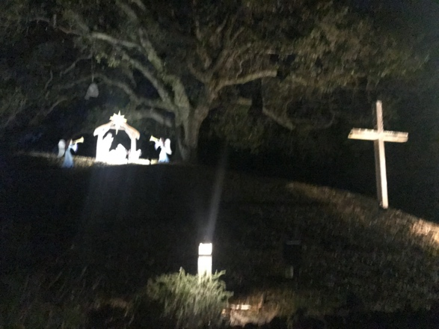
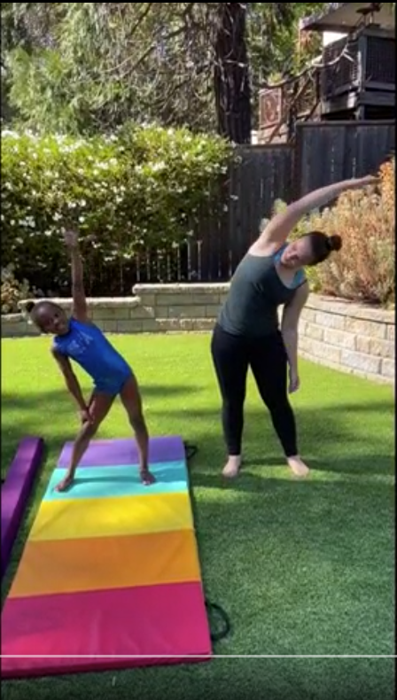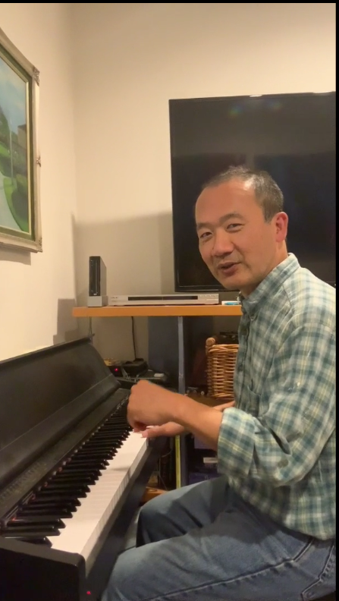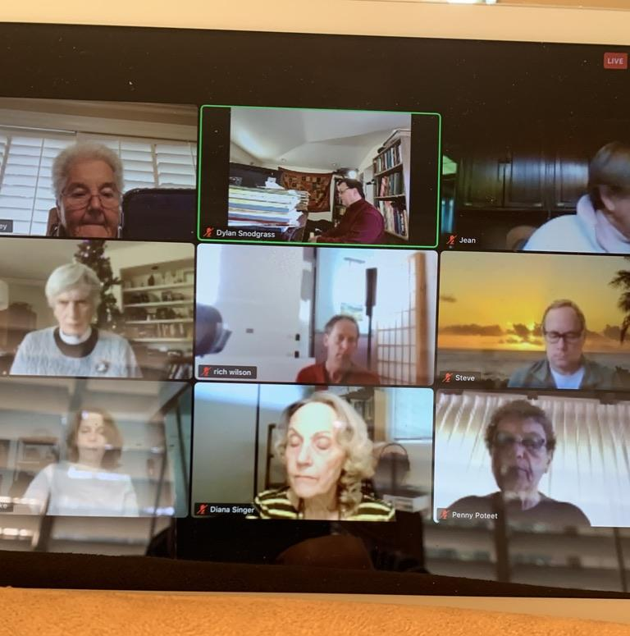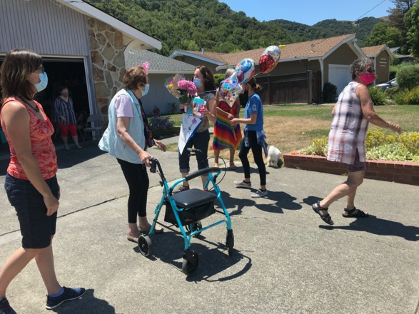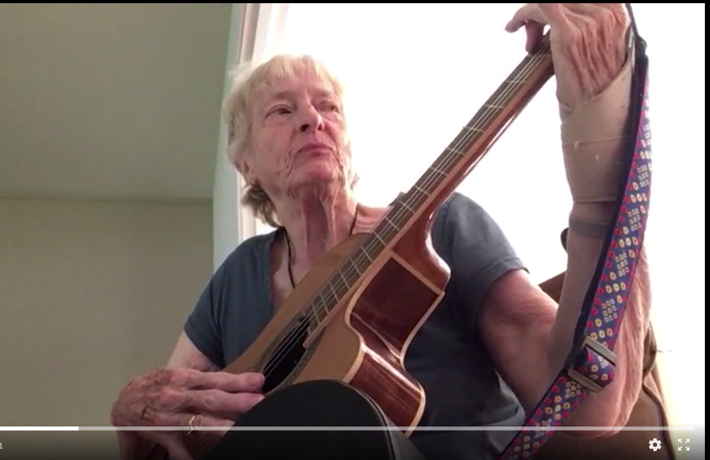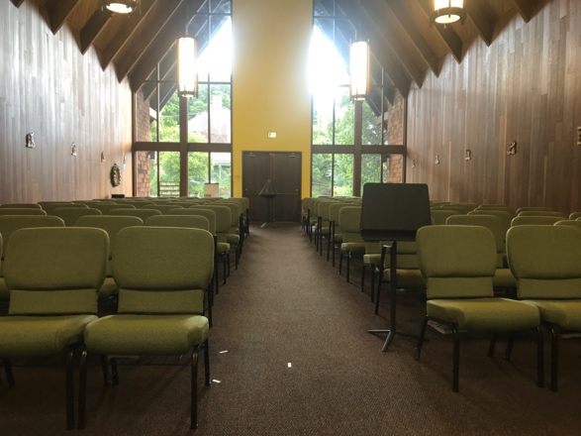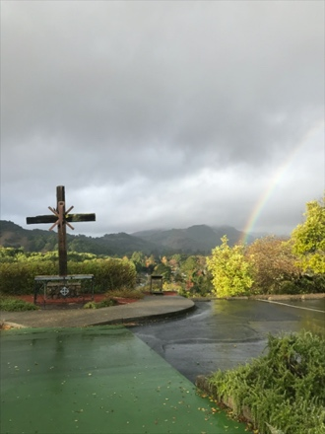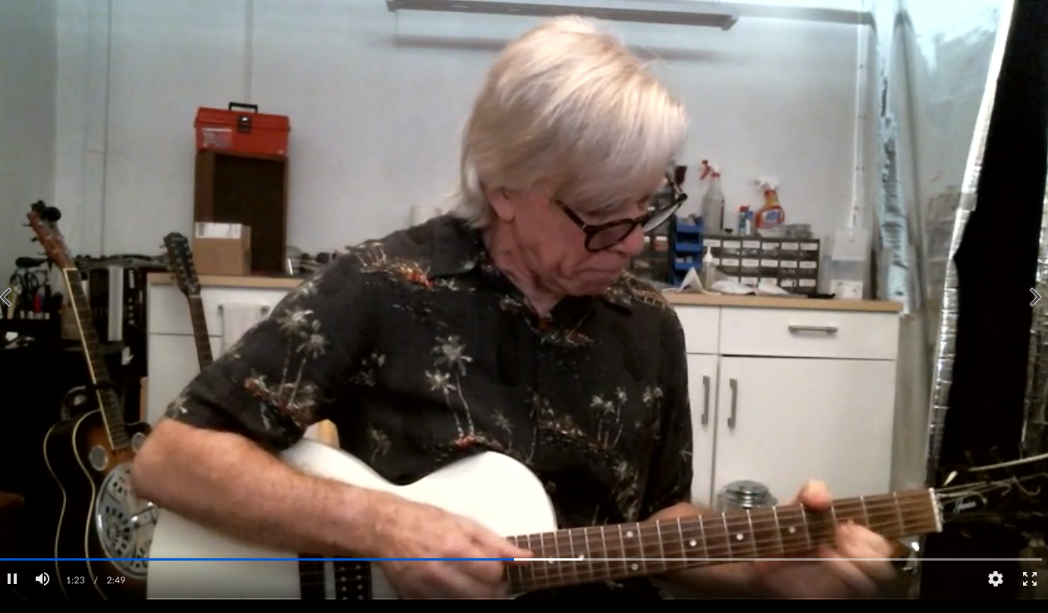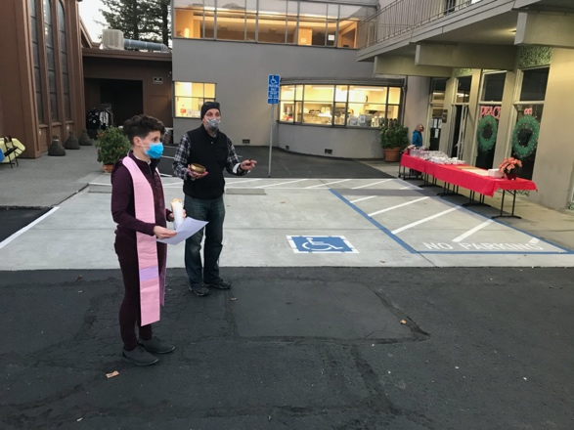
EPISCOPAL CHURCH OF THE NATIVITY
ANNUAL REPORT 2020

Presented to the annual meeting on January 31, 2021

By ZOOM: https://us02web.zoom.us/j/85222162126 By Phone: +1 408 638 0968

Meeting ID: 852 2216 2126

AGENDA

Opening Prayer and Review of Official Acts

Senior Warden Welcome and Review of 2020

Thank you to Vestry members who have fulfilled their service
Jim Huang
Katy Kenney (serving out the remainder of Phil Sandahl’s term)
Judy Richardson
Rich Wilson

Ministry and Budget Reports

Parish Approval of the Budget

Nominations, Election and Commissioning

New Vestry Members: Deanery:
Norma Barr 2024 Ruth Baney
Jean Heine 2024 Amanda Cairo
Katy Kenney 2024
Penny Poteet 2024
Carl Robinett, 2022 (1 year term)

Continuing Vestry Members
Doyle Crosby (2022) Mary Love (2023)
Dick Heine (2022) Jane Hassinger (2023)
Kathy Schlegel (2022) Susan Pick (2023)
Nina Woods (2022) Susan Monahan (2023)

Visioning: Who are we called to Be?

Closing Prayer

Official Acts 2020

Deaths

Susan Parkinson, January 30, 2020

Ava Jean Brumbaum, February 2, 2020

Bud Donaldson, April 7, 2020

Rick Tullis, April 8, 2020

Phillip Sandahl, April 21, 2020

Myrna Snyder, August 31, 2020

Sybil Skinner, September 13, 2020

Membership Transfers

DeeDee Nelson

Pastoral Letter from the Rector to Church of the Nativity
The Rev. Kirsten Snow Spalding, for the Annual Meeting on January, 31, 2021

As I prepared to write the letter to you, I thought about St. Peter’s pastoral letter to his church. The author of the letter (who might not have been Peter) wrote:
³ His divine power has given us everything needed for life and godliness, through the knowledge of him who called us by^{[d]} his own glory and goodness. ⁴ Thus he has given us, through these things, his precious and very great promises, so that through them you may escape from the corruption that is in the world because of lust, and may become participants of the divine nature. ⁵ For this very reason, you must make every effort to support your faith with goodness, and goodness with knowledge, ⁶ and knowledge with self-control, and self-control with endurance, and endurance with godliness, ⁷ and godliness with mutual^{[e]} affection, and mutual^{[f]} affection with love. ⁸ For if these things are yours and are increasing among you, they keep you from being ineffective and unfruitful in the knowledge of our Lord Jesus Christ. (2 Peter 1:2-8.)

2020 was an extraordinary year at Nativity. As for everyone around the world, the pandemic reshaped all Nativity activities. But in this context, God’s call to us to be God’s church in this place has not been shaken or shifted. We have responded to challenges, and we have turned again and again back to God for guidance, sustenance, comfort and inspiration. As the author of Peter’s letter suggested to his community—we have escaped from the corruption of the world by relying on our faith--supported by goodness, knowledge, self-control, endurance, godliness, mutual affection and the love of this community.

We found new ways to pray together and support one another in small Christian Support Groups, Prayer Groups and Discipleship Groups. Members now report that these small groups have become a centering moment in their week and that the groups are supporting members’ individual daily and weekly prayers practices and their individual calls to ministry.

Our formation work has focused on spiritual books, Bible study series and on connecting what we know about our own spiritual lives with our calling to be the Church of the Nativity.

We have grown our partnerships with and support for our neighbors--supporting the Contempo Marin community when they lost their food pantry and the Street Chaplaincy community and parish members who have suffered economic losses since the pandemic. Our regular outreach support for local and international charities has grown significantly as members have contributed generously to the Rector’s discretionary fund.

As we have mourned the deaths of seven parishioners this year, and had many members with medical crises, we have become even more attentive to pastoral care with the lay pastoral care committee making calls, sending cards and reaching out to strengthen our bonds as the Body of Christ here. Our fellowship activities and our pastoral care have overlapped as we found ways to have fun together with the Fall Follies, drive by birthdays and blessings, home craft projects, virtual coffee hours and the dessert exchange. We are caring for one another and extending that care to our broader community of family, friends and neighbors.

Our virtual worship has been consistent—somehow in spite of the new challenges of cameras, computer software, spotty internet and livestreaming we have never missed a week of praising God—occasionally joining St. Paul’s for virtual worship, other times broadcasting from remote locations. Our family services have been a wonderful gift from Rev. Lynn and her family. We’ve experimented, put up with the technical glitches, prayed and prayed, and participated in the sacraments. Our music director, altar guild and assisting priests have done extraordinary and creative things to make our worship beautiful; supported by our Tech Director (Vestry Secretary, Jim Huang). Our local Sunday worshipping community has not disappeared, and God’s word and sacraments have reached new and former parishioners who are living around the world. Our weekday worship services have also continued to provide prayerful moments in our quarantined days.

And on the practical side we have thrived. Our financial systems have gone on-line—an extraordinary shift in how we do business, but we have managed to continue to gather pledges and donations, pay our bills and do our ministries from a strong financial footing. Our members have been extraordinarily generous, continuing their pledges and donations. Our building and grounds have improved, our gardens and watering systems have been upgraded and small building repairs and maintenance have been looked after consistently. Our communications continued through our Nativity Notes Online, our website, social media and our mailings. Our office volunteers have maintained all of our systems, in spite of not being able to come into the office consistently.

The congregation has been led by your vestry, a group of faithful leaders who have brought all of their gifts to the work of being church. We (and I especially) have been supported in every effort by our Senior Warden Kathy Schlegel, Junior Warden Rich Wilson, Deacon Rebecca, Assisting Priests Scott and Lynn and our sister congregations in Northern Marin.

I write this letter with a sense of new calling and mission for Nativity. We have come through this hard year and we are emerging as a community with purpose. We are called be the Body of Christ—the hands and feet, the ears and voices of Jesus. I am curious about how this calling will be expressed in 2021. I trust that God will show us who we must be and what we must do. I give thanks that we have found (what we always knew) that God has given us everything we need. As the author of Peter’s letter encouraged his church, our work to be good and knowledgeable, godly, to show mutual affection and love for one another will not be “unfruitful in the knowledge of our Lord Jesus Christ.”

Blessings to you and your families and friends, with God’s love and mine.
The Rev. Kirsten Snow Spalding

Senior Warden Report

2020 was an unprecedented, uncertain and transition year for Nativity. In February we started off strong with our Strategic Plan of “Following our Baptismal Covenant”. We wanted to continue our apostles’ teaching and fellowship through soup suppers, crab feeds, Hoot sessions, Progressive Dinners, and much more. We wanted to increase Faith Formation with additional educational series, new ways of praying, Sermon Talk-Backs, continuing Renewal Works and offering new Advent and Lenten Retreats.

We wanted to proclaim the Good News of God in Christ through worship, sharing our space, building the church finances and long-term sustainability and stewardship of our building and grounds. We also desired to serve Christ in all persons, love our neighbors as ourselves, strive for justice and peace, and respect the dignity of every human being. We hoped to achieve this through continuing and expanding our outreach and strengthening our environmental stewardship. Wow, what lofty goals!

But then we got “hit in the gut” with Covid-19. No one could predict this pandemic and it certainly changed our perception of what is important in these precarious times for our Church Family. Our first thoughts went to our members’ health and how can we keep them safe while still providing spiritual support. The lockdown of the church forced leadership to communicate with our members on-line or via phone calls.

The most important initial objective was how could we offer our services on-line. Rev. Kirsten had to spend an exorbitant amount of time finding and learning hardware and software upgrades for putting our services live on Facebook, and our Coffee hours and meetings on Zoom. Also, our Pastoral Care Committee was expanded with phone and Facetime sessions with parishioners, and our Rector’s Discretionary Fund was tripled to provide financial support to members and friends in need. Our Street Chaplaincy Outreach shifted to socially distant “to-go” burrito dinners and we started new small groups with St. Paul’s members focused on Christian support, prayer and discipleship.

What was most remarkable was how Nativity parishioners and friends rallied to support our Church and its members. Although we lost several long standing members through death, many members met and even increased their pledges. In addition, we were able to receive a Payroll Protection Program Loan (thank you, Bob Robertson) and had a very successful Fall Follies Virtual Fundraiser that allowed us to meet our financial obligations during 2020. Nativity showed its love and strength!

Nativity has been blessed with Rev. Kirsten’s unfailing leadership, strength and empathy to guide us through the last 9 months. She led and live-streamed our Worship Services, Virtual Funerals and the touching Memorial Service last May. Rev. Scott Sinclair gave extra support to Rev. Kirsten in our “socially distanced” Sunday services, was our Supply Priest and led his Advent Virtual Retreat. Thank you, Rebecca for picking up Zoom and other on-line tools and guiding many on-line spiritual meetings. Rev. Lynn Robinett recruited her family to guide and produce our very successful Second Sunday Family services and Dylan continued supplying our outstanding music both through recordings and live on Sundays– Thank You!

Our members stepped up to offer their special gifts. Ruth Baney has faithfully kept the church office in order and Susan Pick has the important task of keeping our expanded on-line NNO and Facebook communications updated. Jane Hassinger did an exceptional job with the Alter Guild setting up our Sunday and Special Services so our church shined on-line. She also managed our Disaster Preparedness and Church Re-Opening Surveys. Also, thank you to the Nativity members who donated the beautiful outside Nativity Scene that graced our hill at Christmas.

Jim Huang kept the Board Minutes of our Vestry as Clerk and Secretary. Also, Jim took time out of his medical practice to be our recording expert for many Sunday Services and Doyle Crosby has been working with Rev. Kirsten to upgrade our recorded sound system. Susan Monahan successfully revised and managed our finances as Treasurer and Gail Sanfilippo maintained her outstanding role as Assistant Treasurer and incorporating new on-line systems for donations and pledges. Both of these jobs are indispensible! Nativity’s Finance Committee also developed new financial protocols that were approved by the Vestry and the Diocese. A big thank you to Nina Woods and Diana Singer and other members of the Pastoral Care Committee for their outreach to our members in need and to Katy Kenney for keeping track of new members visiting our services on-line.

Dick Heine and Richard Wilson continued their outstanding work taking care of the physical maintenance of the church and Everil Robertson and Mary Love stayed faithful in their caring of our landscaping. Thanks to Doyle Crosby, Katy Kenney and Rebecca Morehouse for their leadership of the Great Commandments/Small Groups. Judy Richardson has continued to successfully shepherd Nativity’s support of the Sanctuary Forest.

Thank you to Susan Pick, Kim Bromley, Amanda Cairo and Carl Robinett for producing our exceptional Fall Follies and to our star-studded group of entertainers who participated. Besides being fun and entertaining, it was an excellent virtual fundraiser event. Now we are talking about the Spring Fling!

I want to give extra thanks to our fantastic Vestry who stepped up during the pandemic participating in extra-long Zoom meetings to provide overall leadership for Nativity; and, of course, Rev. Kirsten whose dedication and guidance was extraordinary and unprecedented.

We will be having a Vestry Retreat in February to plan our objectives and activities for 2021. We look forward to getting back together in 2021 in person but understand we will most probably be continuing our virtual broadcasting of on-line services for those members who physically can’t meet. May we all be able to hug each other soon!

Respectfully submitted,
Kathy Schlegel, Sr. Warden
Deacon’s Annual Report for the 2021 Annual Meeting of the Church of the Nativity

During the strange and challenging year that was 2020, many of us participated in the life of Nativity in new and interesting ways, mostly via Zoom and livestreaming thanks to Kirsten and her support team. As for me:

- I learned to record the gospel as my main participation in the Sunday liturgy. I’ve also joined Kirsten and others (via Zoom)for the Friday noon prayer most weeks.
- I’ve attended vestry meetings and most of our weekly staff meetings.
- The San Quentin Attitudinal Healing group was suspended mid-March. Last spring, several of the congregation volunteered to write notes to the men. Many thanks. I sent out Christmas cards to them on behalf of Kirsten and the congregation. Any and all communication is very much appreciated by the men.
- I joined in The Street Chaplaincy forums via Zoom in the fall in which they updated us on the Burrito ministry and the wonderful work they are doing with a handful of volunteers.
- I enjoy our twice-monthly bible study group, which has now morphed into a weekly meeting. I even lead the discussions when we read Resurrecting Jesus by Adyashanti.
- The Wednesday night meditation group continues to meet via Zoom – we all miss the fellowship of the soup suppers.
- I have led a small group since Nativity with St. Paul’s began the program last summer. There are several groups each meeting specific needs of the group. (see separate report). Our group has met before the 5PM meditation in which most members participate.
- I enjoyed the Buddhist/Christian retreat in July which even via Zoom was particularly restorative. Since then I have been sitting with a Zen group every Tuesday and Friday morning.
- Diocal deacons have been checking in with each other every 2 weeks again via Zoom. So many of them are doing inspiring work during the challenges of the year.

Submitted with gratitude for our Nativity family,
Rebecca Morehouse, Deacon

LECTORS, EUCHARISTIC MINISTERS, AND EUCHARISTIC VISITORS
CHAIR: Diana Singer, Coordinator

COMMITTEE MEMBERS: Those who served during 2020 were Eucharistic Ministers/Lectors: Ruth Baney (cup only), Jean Heine, Penny Poteet, Bob Robertson, Diana Singer, Jean Walker, Rich Wilson; Lectors: Nina Anderson, Juliette Anthony, Nancy Barnes, Kim Bromley, Amanda Cairo, Doyle Crosby, Diane Gibbs, T’sa Hammond, Dick Heine, Karen Henke, Susan Monahan, Susan Pick, Judy Richardson, Everil Robertson, Steve Rule, Kathy Schlegel. Eucharistic Visitors: Ruth Baney, The Rev. Norma Barr, Diana Singer. Resigned from rota in 2020, Eleanor Huang, Joseph Huang, Everil Robertson, Bob Robertson. Deceased in 2020: Eurharistic Minister and Visitor: Phil Sandahl.

COMMITTEE PURPOSE: Lectors are members of the Laity appointed to read the Scripture Lessons during services. Eucharistic Ministers are licensed by the Bishop to serve at the altar. They may light candles, read lessons, lead the Psalm, hold the Gospel Book, lead the Prayers of the People, assist the Celebrant, serve the Chalice, and act as Crucifer. Eucharistic Visitors may take communion to parishioners at home, in hospital, or in nursing facilities.

BRIEF SUMMARY OF 2020 ACTIVITY: Customary assignments by church calendar quarter continued until March when Nativity services went on-line. Eucharistic Minister duties were no longer required for services, so Eucharistic Ministers participated henceforth as Lectors. Eucharistic Visitors were unable to call on parishioners after social distancing was mandated.

OPPORTUNITIES AND CHALLENGES: EMs and Lectors able and willing to video record and submit lessons for services did so from their homes in accord with subsequent quarterly calendar assignments. These recordings were sent to the Nativity office and woven into the virtual services for broadcast through Facebook or ZOOM. We thank Amanda Cairo and Susan Pick for their assistance and instruction.

PRIORITIES/CALENDAR FOR 2021: Eucharistic Ministers and Lectors will continue to provide recorded readings until we are allowed to worship together again at Nativity and resume full duties. We look forward to welcoming back those who took leave for this period.

CONTACT DETAILS FOR FURTHER INFORMATION: Thanks to all who participated this year. Those interested in becoming part of this ministry, please contact Rev. Rebecca or the Committee Chair/Coordinator.

Diana Singer
415-479-6008
dianasinger@gmail.com

COMMUNICATIONS

CHAIR: Susan Pick

COMMITTEE MEMBERS: None at this time

COMMITTEE PURPOSE: To keep the congregation and the extended Nativity community informed about the church’s activities and events

BRIEF SUMMARY OF 2020 ACTIVITY:
- Produced weekly issues of Nativity Notes Online, our email newsletter.
- Provided regular updates on the Nativity in San Rafael Facebook page.
- Created a new Episcopal Churches of Novato and San Rafael Facebook page to reach the congregations of St. Paul’s, St. Francis and Redeemer, in addition to Nativity.
- Created events and other posts on the Marinwood Next Door page.
- Sent supplemental emails via the NNO distribution list as needed.
- Added our weekly virtual services to the Marin Independent Journal (IJ) online Religion Calendar.
OPPORTUNITIES AND CHALLENGES:
- Not all members of our community use email, Facebook, Next Door or Zoom. We can’t be sure we’re reaching everyone.
- While we were not holding services in person, we suspended our usual holiday (Easter and Christmas) advertising in the Marin IJ.
PRIORITIES/CALENDAR FOR 2021:
- Revisit our advertising strategy and schedule.
- Continue to send NNO to the congregation every Tuesday.
- Post to Facebook and Next Door at least two times a month.
CONTACT DETAILS FOR FURTHER INFORMATION:
Susan Pick

415-847-0377 susanrows@yahoo.com

CHOIR

CHAIR:
Jean Heine

COMMITTEE MEMBERS:
Diana Singer, Everil Robertson, Sybil Skinner

COMMITTEE PURPOSE:
To assist with music for worship

BRIEF SUMMARY OF 2020 ACTIVITY:
Sang for services in January and February before Covid restrictions. We were honored to sing for Sybil’s memorial.

OPPORTUNITIES AND CHALLENGES:

PRIORITIES/CALENDAR FOR 2021:

CONTACT DETAILS FOR FURTHER INFORMATION:

Jean Heine

415-479-6343

ALTAR GUILD

CHAIR: Jane Hassinger

COMMITTEE MEMBERS: Ruth Baney, Leslie Betts, Diane Crosby, Jane Hassinger, Nancy Chapman, Susan Pick, Gail Sanfilippo, Nina Woods

COMMITTEE PURPOSE: The mission of the Altar Guild is to be the mediator between the timelessness of our traditions and worship and calls of new centuries and conditions. We “set the table” for weekly services—virtual and in person—and strive to make the church setting and services attractive and inviting for the glorification of God and the comfort of the Nativity community.

BRIEF SUMMARY OF 2020 ACTIVITY: During the first six months of the pandemic, Altar Guild scaled back participation in the eucharist preparation as all current members are in at-risk categories due to age or infirmity. A few members assisted the priests in assembling the cup throughout that time. Later, volunteers agreed to individual weekly assignments of setup assistance. Some members participated in preparation and distribution of Holy Week packets and later in the year, Advent packets. We also scaled back the greening of the church for Christmas, but added displays of various Nativity scenes in the front windows. We helped develop a contract tracing system and maintained sanitizing supplies for outdoor Sunday services and funerals.

OPPORTUNITIES AND CHALLENGES: The pandemic was a major challenge that we tried to meet by adjusting setup and decoration for live-streamed services. We converted the floral commemoration system to a virtual one that is published in the Nativity Notes Online and still generates an income stream. There are membership opportunities for parishioners who would like to join the Altar Guild.

PRIORITIES/CALENDAR FOR 2021: We look forward to in-person services when they resume, but in the meantime will remain flexible to meet the needs of the priests and parishioners.

CONTACT DETAILS FOR FURTHER INFORMATION:
Jane Hassinger
hassingerjane@gmail.com or nativityonthehill@gmail.com

DIRECTOR OF FACILITIES
CHAIR: Dick Heine
COMMITTEE MEMBERS:
COMMITTEE PURPOSE:
Coordinate activities related to repair and maintenance of facilities
BRIEF SUMMARY OF 2020 ACTIVITY:
- Attempted to get County to designate no parking zone at bottom of front steps – neighbors objected and County disallowed
- Continuing problems with irrigation systems. Mary Love and Everil Robertson have volunteered to take on irrigation and landscaping reposnsibiliy – thank you!
- Plumbing problems
- Tree trimming on east side
- Gutters cleaned
OPPORTUNITIES AND CHALLENGES:
Ongoing
PRIORITIES/CALENDAR FOR 2021:
New handyman to provide estimates for several repair projects – parking lot cross, walkway lights, siding shakes
CONTACT DETAILS FOR FURTHER INFORMATION:
Dick Heine
415-479-6343

FACILITIES USAGE COMMITTEE
CO-CHAIRS: Rev. Kirsten, Kathy Schlegel, Everil Robertson
COMMITTEE PURPOSE: Support good stewardship of our building and grounds by sharing them with the greater community. Serve as point of contact for individuals and groups wishing to use building and/or grounds for activities in keeping with Nativity’s mission and values. Enforce compliance with insurance, safety, administrative, and other requirements.
BRIEF SUMMARY OF 2020 ACTIVITY: We were committed to complete adherence to state, local, and diocesan directives regarding pandemic safety throughout the year. Use of our building was essentially halted for both Nativity activities and those of outside groups or individuals. Here are some observations and thoughts:
- Our hilltop became an even more popular destination for dog-walkers, trail-hikers, kids with too much energy to stay indoors all day, and folks who needed a sacred space for meditation and prayer at our outside altar.
- Marin Humane Society was able to continue scent-training and other doggie activities in our parking lot once small groups were permitted to safely meet outdoors.
- Our six 12-step groups (3 AA, 1 OA, 1 MA, and 1 ACA) were creative in the use of Zoom, GoogleMeet, car meetings, and other means of providing experience, strength, and hope for addicts. We promised we would hold their time slots and locations until we are able to reopen. We are very grateful that the groups continued to pay donations even though their numbers sometimes dwindled due to difficulty in maintaining personal contact.
- Some of the events we had to defer to a covid-free future: spring and summer camps for the Marin Girls Choir; hosting a relay station for Ragnar Relay Races; music recitals; and the sharing of space and ministries with Marin International Church, a proposed gathering of home-churches serving several immigrant communities.
OPPORTUNITIES:
- Re-opening our beautiful facilities when the time is right. We have kept in touch with our group contacts, and are confident that we will be able to resume plans with most if not all of them.
- Reaching out to promote our facilities for other groups and individuals.
- Supporting Nativity’s financial position through the stewardship of our building and grounds.
CHALLENGE: The Pandemic—not only the closure of our building, but how our community and society will be changed when we are finally able to regather.
PRIORITIES/CALENDAR FOR 2021: Continued mask-wearing, hand-washing, social-distancing, patience, and prayers for progress toward regathering.
CONTACT DETAILS FOR FURTHER INFORMATION:
nativityonthehill@gmail.com 415-479-7023
everil.robertson@icloud.com 415-497-9159

GROUNDS COMMITTEE

CO-CHAIRS: Mary Love and Everil Robertson

COMMITTEE PURPOSE: Supervise the work of repairing, improving, and maintaining Nativity’s outdoor infrastructure and grounds
.
BRIEF SUMMARY OF 2020 ACTIVITY:
- Irrigation: Repair of decades-old system, including pressure regulation; meeting MMWD compliance as to backflow regulation.
- Wildfire mitigation improvements throughout the campus: Removal of flammable undergrowth, plantings, and dead branches; “topping up” of tree branches; removal of branches overhanging/touching the church structure.
- Repair of playground fence
- Front slopes (areas in front of the church, on either side of the steps up from the sidewalk): Clearing of dead plantings, wild growth (berry bushes, poison oak, and other underbrush); improved irrigation coverage, soil amendment, and mulch covering. New planting deferred until spring 2021.
- Side slopes (areas between parking lot and church structure): improved irrigation coverage, soil amendment, and mulch coverage; removal of flammable plantings, replaced with drought/fire-resistant blooming and foliage plants.
- Monthly maintenance: weeding, pruning, weed-whacking, blowing, etc.

OPPORTUNITIES:
- Planting of front slopes.
- Repair of irrigation and improved plantings on parking-lot islands.
- Fencing or plantings along east patio and sidewalk, to prevent falls/poison oak exposure on the hillside.

CHALLENGES:
- Funding above maintenance level.
- Continuing wildfire danger.
- Occasional vandalism to outdoor structures (e.g., parking lot cross) and irrigation, plantings.

PRIORITIES/CALENDAR FOR 2021 IF FUNDING IS AVAILABLE:
- Spring: Fire/drought resistant, shade-loving plantings on front slopes.
- Spring: repair irrigation and improve plantings on parking-lot islands.
- Before we reopen: Place fencing or plantings along patio and sidewalk on east side of the church
- Late Spring/Summer: thorough clean-up of underbrush and dead limbs, etc.; clearing of defensible space around the property

CONTACT DETAILS FOR FURTHER INFORMATION:
Mary Love: 510-334-6559, hoedog2@comcast.net
Everil Robertson: 415-497-3 39159, everil.robertson@icloud.com

Newcomers Committee
CHAIR: Katy Kenney

COMMITTEE MEMBERS: Just me!!....

COMMITTEE PURPOSE: Welcome visitors and new members

BRIEF SUMMARY OF 2020 ACTIVITY:
I came on to the vestry to fill in for Phil Sandhal; and during quarantine. The most I have been able to do is watch Facebook for new names and greet them. I have a list of these people that I forward to Kirsten for a more personal welcome.

OPPORTUNITIES AND CHALLENGES:
Due to Covid, I’m limited to what interaction I can have with newcomers and visitors. Hopefully, welcoming them on Facebook will make them feel good about returning to the virtual services until we can meet in person again.

PRIORITIES/CALENDAR FOR 2021:
Continue doing what I am doing. When we are allowed to meet again in person, I plan to reach out to these people and invite them to an in person service. Hopefully, we could have a special newcomer coffee hour.

CONTACT DETAILS FOR FURTHER INFORMATION:

Katy Kenney
415-382-0396
Kenn1030@aol.com

OUTREACH COMMITTEE

CHAIR: Ruth Baney & Rev. Rebecca

COMMITTEE MEMBERS: Rev Rebecca, Ruth Baney, Diane Crosby, Nancy Barnes, Gail Sanfilippo, Diana Singer
COMMITTEE PURPOSE: Outreach within our community for organizations supported by our members.
BRIEF SUMMARY OF 2020 ACTIVITY: Due to the Covid pandemic, many of our regular activities were curtailed. We did manage to give gift cards and/or checks to Ritter House in lieu of Christmas Tree, support Marin Humane Society with cookie sales at Coffee Hour and pledge support to Marin Street Chaplaincy. Rev Kirsten contributed $100 each to charities supported by June graduates: ASPCA, Oceana, Canal Alliance, Rady Children’s Hospital – SD, Black Lives Matter, Amigos for Christ, NAACP, St. Baldricks, Play Marin, ACLU.
OPPORTUNITIES AND CHALLENGES:

PRIORITIES/CALENDAR FOR 2021: More in person activities such as Street Chaplaincy, Ritter House and Food Bank.

CONTACT DETAILS FOR FURTHER INFORMATION:
Ruth Baney
415-472-7030
rrbaney@aol.com

Rev. Rebecca
415-233-2093
Rebecca6416@gmail.com

OFFICE VOLUNTEERS

CHAIR: Ruth Baney

COMMITTEE MEMBERS: Joel Solomon, Everil Robertson, Gail Sanfilippo, Ruth Baney, Susan Pick, Jane Hassinger

COMMITTEE PURPOSE: To provide office live coverage weekdays from 10-12 am

BRIEF SUMMARY OF 2020 ACTIVITY: Due to Covid we ceased daily coverage in early March. Many continued to complete their assigned tasks from home. These would be picking up phone messages, mailing copies of NNO to non- computer users

OPPORTUNITIES AND CHALLENGES: There is a need for additional volunteers to cover illness and vacations.

PRIORITIES/CALENDAR FOR 2021: Back to In-Church worship and on-site daily coverage.

CONTACT DETAILS FOR FURTHER INFORMATION:
Ruth Baney
415-472-7030
rrbaney@aol.com

Pastoral Care Committee

CHAIR: Nina Woods and Diana Singer

COMMITTEE MEMBERS: Ruth Baney, Norma Barr, Leslie and Jamie Betts, Kim Bromley, Nancy Chapman, Jane Hassinger, Katy Kenney, Jong Lee, Susan Monahan, Susan and Charlie Pick, Penny Poteet, Everil Robertson, Gail Sanfilippo, and The Rev. Scott Sinclair

COMMITTEE PURPOSE: Providing telephone calls, notes and emails, meals and prayers. The committee members have responded eagerly to help with this ministry.

BRIEF SUMMARY OF 2020 ACTIVITY: We meet with Rev. Kirsten each month to discuss reported and potential needs of parish congregants and in what welcome manner we might address them. Committee members are contacted to provide the appropriate support.

OPPORTUNITIES AND CHALLENGES: Reaching out to those in need, gives us the opportunity to continue building and strengthening the sense of community between newer or peripheral parishioners and long-time members. At present the challenge of pandemic social distancing limits our ability for close, in-person contact with parish members.

PRIORITIES/CALENDAR FOR 2021: We are looking forward to being able to drive members to their appointments as needed and socialize in person.

CONTACT DETAILS FOR FURTHER INFORMATION: When needs arise, parishioners are urged to notify Rev. Kirsten or the committee chairs.

Nina Woods/415-479-6690 nina@woodshome.com

Diana Singer/415-479-6008 dianasinger@gmail.com
Contemplative Prayer
CHAIR: The Rev. Rebecca Morehouse
COMMITTEE MEMBERS: Rev. Scott Sinclair, Ms. Ruth Baney, Ms. Norma Barr, Ms. Gail Sanfilippo, Ms. Nina Woods
COMMITTEE PURPOSE: Through prayer to grow individually and corporately; to glorify God; to intercede for others, especially those in great need.
BRIEF SUMMARY OF 2020 ACTIVITY: Prior to Covid 19, we met in person each Wednesday evening at 5:00 P.M. for half an hour of contemplative silence followed by Compline and soup and bread. After the arrival of Covid, we continued to meet at the same time but on zoom and without sharing a meal. In the fall we joined the small group association and started to meet at 4:30 to share our prayer concerns and thanksgivings and then to proceed to silence and Compline (or Night Prayer from the New Zealand Prayer Book).
OPPORTUNITIES AND CHALLENGES: Giving up our shared meal was painful.
Meeting and praying by zoom took some adjustment, but after we got used to it, zoom worked well. Sharing prayer concerns and thanksgivings prior to silence and Compline helped bond the group.
PRIORITIES/CALENDAR FOR 2021: As soon as possible resume meeting in person and sharing a meal.
CONTACT DETAILS FOR FURTHER INFORMATION:

The Rev. Rebecca Morehouse
415-233-2093
rebecca6416@gmail.com
The Rev. Scott Sinclair
415-521-6095
scottgsinclair@hotmail.com

The zoom number is 854 964 9442; there is also a link at nativityonthehill.org

THURSDAY BIBLE STUDY
CHAIR: Rev Kirsten, Rev Rebecca and others

COMMITTEE MEMBERS: Rev Kirsten, Rev Rebecca, Rev Carol Luther, Norma Barr, Kathy Burt, Mary Love, Ruth Baney, Mary Aversano

COMMITTEE PURPOSE: Through reading and studying scripture and other spiritual books, we aim to deepen our relationship with God, Jesus the Christ, the church and each other. The texts we read lead to interesting and often challenging discussions. During COVID, we meet via Zoom thanks to Rev Kirsten, Nativity’s tech guru. Please join us, all are welcome.

BRIEF SUMMARY OF 2020 ACTIVITY: We are currently reading “Universal Christ – How a Forgotten Reality Can Change Everything We See, Hope for, and Believe” by Richard Rohr.

OPPORTUNITIES AND CHALLENGES: Always looking for new members.

PRIORITIES/CALENDAR FOR 2021:

CONTACT DETAILS FOR FURTHER INFORMATION:

Rev. Kirsten
510-207-6346
kss@well.com

Rev Rebecca
415-233-2093
Rebecca 6416@gmail.com

Street Chaplaincy
CHAIR: GAIL SANFILIPPO

COMMITTEE MEMBERS: KIM BROMLEY, KAREN HENKE, REV. REBECCA MOREHOUSE,EVERIL ROBERTSON, JANE HASSINGEER, SCOTT SINCLAIR, DIANA SINGER,ARLEEN LITTLEFIELD

COMMITTEE PURPOSE: A BIG PART OF OUR MINISTRY IS JOINING OUR GUESTS AT DINNER AND ENJOYING CONVERSATION WITH THEM

BRIEF SUMMARY OF 2020 ACTIVITY: UNFORTUNATELY WE DIDN’T DO OUR USUAL DINNERS BECAUSE OF COVID. WE HOPE 2021 WILL BE DIFFERENT

OPPORTUNITIES AND CHALLENGES: DEALING WITH COVID AND MAKING SURE THAT OUR HOMELESS ARE BEING TAKEN CARE OF

PRIORITIES/CALENDAR FOR 2021: HOPEFULLY COVID WILL BE UNDER CONTOL AND WE WILL BE ABLE TO MEET AND FEED THE NEEDY.

CONTACT DETAILS FOR FURTHER INFORMATION:
GAIL SANFILIPPO – GAILSAN07@GMAIL.COM

FAMILY MINISTRY
CLERGY and COMMITTEE: The Rev. Lynn Oldham Robinett with Amanda Cairo, Kim Bromley, Karen Henke and Rev. Kirsten
BRIEF SUMMARY OF 2020 ACTIVITY: During quarantine, our primary family ministry activity has been our Second Sunday services, led by Rev. Lynn with her children (Carl, Kelly and Helen) providing music and readings. This concise service with simplified readings and sermon, easy to sing hymns and movements is a favorite for everyone in the congregation. We honored our graduates with a June program of discretionary account donations chosen by each of the students. The “grad gallery” with their pictures and charity choices lives on the Family Ministry page of our website. Our Christmas pageant was a fantastic telling of the Christmas story with our children reading, and acting out the pageant on home videos (hurrah Kim and Amanda). Our families have led a few service projects including gathering donations for the Marin Humane Society on St. Francis Day. The youth contributions to the Fall Follies Fundraiser (especially Carl Robinett as co-host), were very special.
OPPORTUNITIES AND CHALLENGES: During the pandemic we have missed seeing our younger members in worship, but love occasionally seeing them at Zoom coffee hour and for our outdoor activities. We look forward to more creative ways to work with our families to provide spiritual support and growth and engage the young members without contributing to kids’ zoom fatigue. We are exploring a partnership with a youth movement and theater teacher to offer classes on our labyrinth when it is possible to gather outside again. We welcome any suggestions for family activities and will happily support any youth service projects.
PRIORITIES/CALENDAR FOR 2021: We look forward to continuing our Second Sunday Family Services. We will offer a confirmation class for young people this spring and look forward to confirmations with Bishop Marc at Grace Cathedral in May or June.
CONTACT DETAILS FOR FURTHER INFORMATION:
Rev. Lynn Robinett can be reached at (415) 747-1920‬ or by email at lynnmor@gmail.com. ‬‬

TREASURER REPORT
CHAIR: Susan Monahan

COMMITTEE MEMBERS: None

COMMITTEE PURPOSE: To pay bills for the church bi-monthly. Prepare financial reports for the Vestry on a monthly basis, work with the paid bookkeeper to resolve any issues, coordinate with the Assistant Treasurer, Gail Sanfilippo. Manage all payroll related activities. Complete and submit paperwork required by the County of Marin, the Diocese and Insurance company.

BRIEF SUMMARY OF 2020 ACTIVITY: I became Treasurer in mid-June after Bob Robertson left the position. Bob had done an excellent job of transitioning to online bill pay making the position work more easily during COVID. Managed PPP loan funds after Bob Robertson had successfully received a loan. Applied for PPP forgiveness.

OPPORTUNITIES AND CHALLENGES:

PRIORITIES/CALENDAR FOR 2021: Obtain another POPP loan if eligible.

CONTACT DETAILS FOR FURTHER INFORMATION:
Susan Monahan
415-886-1919
sfm@monahanpacific.com3

FINANCE COMMITTEE

CHAIR: Susan Monahan

COMMITTEE MEMBERS: Diane Gibbs, Susan Monahan, Duane Johnson

COMMITTEE PURPOSE: The Finance Committee mee4ts quarterly to review financial reports. The Member’s comments are reported to the Vestry for their consideration.

BRIEF SUMMARY OF 2020 ACTIVITY: The committee met via Zoom and phone to review financial reports and comment on the budget. The committee has moved all banking to on-line and have been administering the PPP loan we received in the Spring. Many thanks to the Committee for their concerns and attention to Nativity’s finances. A special thanks to Bob Robertson for his service as Treasurer.

OPPORTUNITIES AND CHALLENGES:

PRIORITIES/CALENDAR FOR 2021: Recruit one to two new members to the committee.

CONTACT DETAILS FOR FURTHER INFORMATION:
Susan Monahan
415-686-1919
sfm@monahanpacific.com33

Roster of Ministry Leaders

(Questions about ministries can be directed to the following people. Apologies to all whom we have missed on this list. A tribute to Nativity’s vitality, there are too many ministry leaders to count. See Reports for listing of committee members.)

Vestry 2021
Norma Barr (*standing for election 1.31.21)
Doyle Crosby
Jane Hassinger
Dick Heine
Jean Heine(*standing for election 1.31.21)
Katy Kenney(*completed Phil Sandahl’s term standing for election 1.31.21)
Mary Love
Susan Monahan
Susan Pick
Penny Poteet (*standing for election 1.31.21)
Carl Robinett (*standing for election 1.31.21, student seat)
Kathy Schlegel, Senior Warden
Nina Woods

Rev. Kirsten (voting ex-officio)
Rev. Rebecca (ex-officio)

Rector, The Rev. Kirsten Snow Spalding
Assisting Priests, The Rev. Scott Gambrill Sinclair and The Rev. Lynn Oldham Robinett
Deacon, The Rev. Rebecca Morehouse

Deanery Representatives, Amanda Cairo, Ruth Baney

FINANCE AND OPERATIONS
Treasurer, Susan Monahan (and Finance Committee Convener)
Assistant Treasurer, Gail Sanfillipo
Church Office, Ruth Baney
Stewardship 2020 (for 2021) Kathy Schlegel
Fundraising, Susan Pick

WORSHIP MINISTRIES
Music Director, Dylan Snodgrass
Choir, Jean Heine
Altar Guild, Jane Hassinger
Eucharistic Ministers and Readers, Diana Singer
Contemplative Prayer and Compline, Rev. Rebecca and Rev. Scott
Friday Midday Prayer, Rev. Kirsten
Family Ministry, Karen Henke and Rev. Lynn
Christmas Pageant, Kim Bromley and Amanda Cairo

FACILITIES AND GROUNDS
Director of Facilities, Dick Heine
Garden Coordination, Mary Love and Everil Robertson
Facility Rentals, Everil Robertson

OUTREACH
Outreach Committee, Ruth Baney and Rev. Rebecca
Recycling Project, Elizabeth Buskirk and Marian Marsh
Street Chaplaincy and Wellness Gathering, Gail Sanfillipo and Rev. Kirsten
Caregiver Support Group, Rev. Kirsten
Food Bank, Kim Bromley
Ritter House Support, Susan Pick
Downtown Streets Team, Everil Robertson
San Quentin Ministry, Rev. Rebecca

FORMATION
Bible Study, Rev. Kirsten and Rev. Rebecca
Cursillo and Kairos, Jean Heine, Ruth Baney and Penny Poteet
Small Group Ministry: Katy Kenney, Deborah Spivey, Rev. Kirsten, Rev. Rebecca, Rev. Scott, Doyle Crosby
Seasonal Retreats, Rev. Scott

PASTORAL CARE
Pastoral Care Committee, Diana Singer and Nina Wood

Church of The Nativity | 2020 Budget | 2020 Actual | 2021 Budget
Income:
Pledge - Income | $135,387.00 | $131,822.88 | $134,246.00
Pledge - Prior Year | $1,000.00 | $2,195.00 | $1,000.00
Plate Offering | $13,562.00 | $2,580.00 | $7,000.00
Donation Income | $3,102.00 | $1,497.78 | $3,000.00
Rental Income/ 12 Step Income | $5,093.00 | $3,172.00 | $5,000.00
Fundraising | $11,773.00 | $3,803.06 | $7,500.00
Misc. Income |  | $120.00
Upstairs Income |  | $9,600.00 | $9,600.00
PPP Loan |  | $19,300.00
Total Income: | $169,917.00 | $174,090.72 | $167,346.00
Expenses:
Diocese Expenses:
Altar Guild Membership | $75.00 | $0.00 | $75.00
Diocesan Assessment | $16,816.00 | $16,836.24 | $18,211.00
Audit - Diocese | $600.00 | $0.00 | $600.00
Salaries, Wages & Pensions:
Payroll Expense | $75.00 | $0.00
Rector - Salary, Housing & SET | $65,782.00 | $65,782.03 | $66,834.00
Rector - Ins. Benefits | $411.00 | $465.08 | $450.00
Rector - Pension | $11,841.00 | $9,808.92 | $14,063.00
Salary - Supply Priest | $1,828.00 | $0.00 | $1,000.00
Salary - Music Director | $18,038.00 | $17,337.60 | $18,327.00
Salary - Supply Musician | $1,500.00 | $150.00 | $1,500.00
Social Security Taxes - FICA | $1,550.00 | $1,326.34 | $1,500.00
Clergy Expenses:
Rector - Travel | $600.00 | $27.53 | $600.00
Rector - Continuing Education | $200.00 | $0.00 | $200.00
Deacon - Discretionary Fund | $350.00 | $350.00 | $350.00

Church of The Nativity | 2020 Budget | 2020 Actual | 2021 Budget
Program Expenses:
Outreach Gifts | $1,500.00 | $1,372.99 | $1,500.00
Fund Raising Expense | $2,872.00 | $0.00 | $1,750.00
Worship Expenses:
Worship - Misc. Front of Church | $1,700.00 | $875.35 | $1,200.00
Parish Supplies - Back of Church | $500.00 | $100.53 | $300.00
Music Expenses | $500.00 | $542.50 | $500.00
Altar Guild | $0.00 | $81.71
Fellowship Expenses:
Fellowship/Hospitality -Coffee | $1,000.00 | $221.34 | $500.00
Christian Education | $500.00 | $61.88 | $300.00
Theological Education | $200.00 | $200.00 | $200.00
Youth Group Ministry | $1,000.00 | $918.52 | $500.00
General & Admin. Expenses:
Bank Charges | $341.00 | $556.55 | $500.00
Bookkeeper | $3,150.00 | $3,120.00 | $3,300.00
Computer Software | $490.00 | $937.93 | $500.00
Computer Tech Support | $325.00 | $731.33 | $325.00
Audio/Visual Equipment |  |  | $1,500.00
Copier - Expenses | $3,780.00 | $1,415.41 | $2,000.00
Copier - Lease | $3,300.00 | $2,430.53 | $3,000.00
Internet | $900.00 | $1,001.45 | $1,000.00
Insurance - Property & Liability | $10,340.00 | $9,968.00 | $10,040.00
Insurance - Worker's Comp | $300.00 | $498.00 | $300.00
Janitorial | $1,800.00 | $1,162.25 | $1,400.00
Landscaping | $3,640.00 | $4,230.43 | $6,000.00
Licenses/Dues/Registration Fee | $0.00 | $48.29 | $50.00
Office Supplies | $750.00 | $538.96 | $600.00
Postage | $500.00 | $513.60 | $500.00
Property Tax - Marin County | $2,639.00 | $3,224.46 | $3,842.36
Publicity | $1,700.00 | -$408.76 | $1,000.00
Repairs & Maintenance | $2,000.00 | $2,086.18 | $4,000.00
Telephone | $850.00 | $1,002.40 | $850.00
Church of The Nativity | 2020 Budget | 2020 Actual | 2021 Budget
Utilities Expenses:
Electricity | $2,900.00 | $1,863.89 | $2,000.00
Gas | $3,150.00 | $1,717.14 | $2,300.00
Sanitary/Garbage | $1,800.00 | $1,910.99 | $2,000.00
Water | $2,431.00 | $2,097.88 | $3,000.00
Subtotal Total Expenses: | $176,624.00 | $157,205.47 | $180,567.36
Net Ordinary Income: | -$6,707.00 | $16,885.25 | -$13,221.36
Additional Planned Transfers:
Sabbatical Reserve | $1,000.00 | $1,000.00 | $1,000.00
Rector Discretionary Fund | $750.00 | $750.00 | $750.00
Total Expenses | $178,374.00 | $158,955.47 | $182,317.36
Net Income/Expense | -$8,457.00 | $15,135.25 | -$14,971.36

