Episcopal Church of the Nativity
Second Sunday Family Service
on Facebook Live
10 a.m.
Sunday August 8th

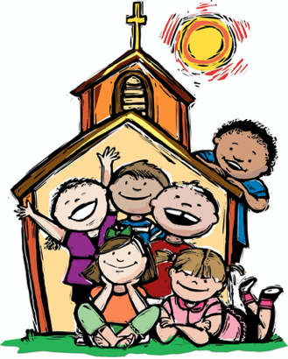

Rev. Kirsten Snow Spalding, Rector - Preaching and Presiding
Rev. Scott Gambrill Sinclair, Assisting Priest
Rev. Lynn Oldham Robinett, Assisting Priest
Rev. Rebecca Morehouse, Deacon

We Gather Together
Please take an index card and crayon and write or draw a prayer which will be collected during the service. While we’re worshipping online, you can type your prayers into the comment box on the Facebook site. Also please grab a stone which will be used during our confession.

Song “We Are the Church”

Refrain:
I am the church! You are the church!
We are the church together!
All who follow Jesus,
all around the world!
Yes, we're the church together!
1. The church is not a building;
the church is not a steeple;
the church is not a resting place;
the church is a people.
(Refrain)
2. We're many kinds of people,
with many kinds of faces,
all colours and all ages, too
from all times and places.
(Refrain)
3. Sometimes the church is marching;
sometimes it's bravely burning,
sometimes it's riding, sometimes hiding;
always it's learning.
(Refrain)
4. And when the people gather,
there's singing and there's praying;
there's laughing and there's crying sometimes,
all of it saying:
(Refrain)
5. At Pentecost some people
received the Holy Spirit
and told the Good News through the world
to all who would hear it.
(Refrain)

We Pray Together

Priest: Blessed be God: Father, Son & Holy Spirit.
People: And blessed be God’s kingdom, now and forever. AMEN
All: Almighty God to you all hearts are open, all desires known, and from you no secrets are hid: Cleanse the thoughts of our hearts by the inspiration of your Holy Spirit, that we may perfectly love you, and worthily magnify your holy Name; through Christ our Lord. Amen.

Priest: Lord, have mercy.
All: Christ, have mercy.
Priest: Lord, have mercy.

Priest: The Lord be with you.
All: And also with you.
Priest: Let us pray.
Grant to us, Lord, we pray, the spirit to think and do always those things that are right, that we, who cannot exist without you, may by you be enabled to live according to your will; through Jesus Christ our Lord, who lives and reigns with you and the Holy Spirit, one God, for ever and ever. Amen.

Bible Story and Discussion “John 6:35, 41-51”

Song “I Am the Bread of Life” Hymn 335

During the song please send in any prayers you have and people or things for which you would like prayer.

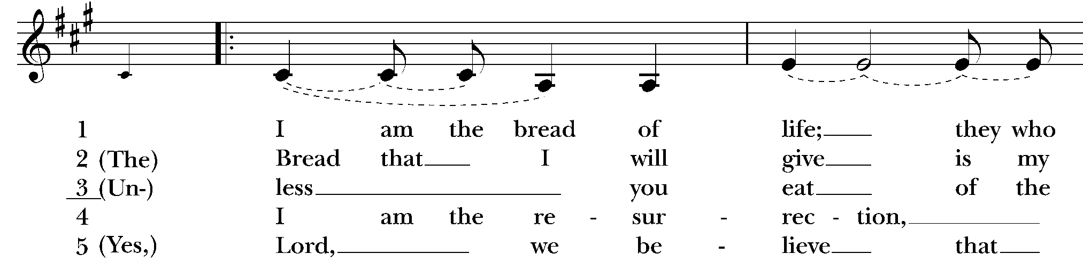
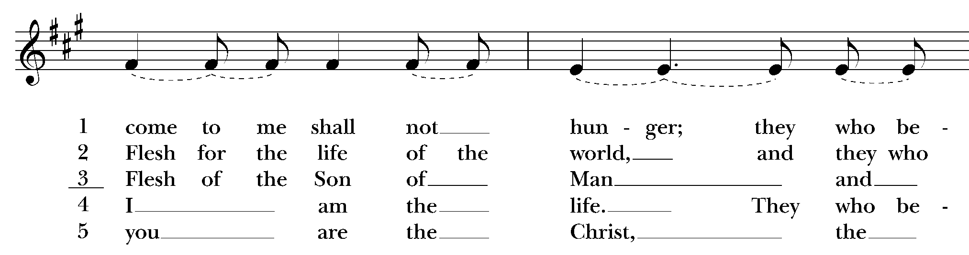

Prayers of the People

Priest: Let us pray, sharing with God our cares and our thanks.
People: God, hear our prayer.

All the prayer cards will be read. After each one, the people will respond:
God, hear our prayer.

Pray for our members: Carissa, Marge, Juliette, Dan, Donna, Jim, Leslie, Duane, Norma, Steve, Nancy, Jamie, and Dylan, and our friends and neighbors; Katherine, Ed, John, Mary P., Nathaniel, Les, Eric and Julie, Bob, Ronald and Emily, Polly, Sylvia, Young, Kevin, Sarah, Tom and Jane, Robert B, Jayden and Leah.

Priest: Above all, we thank you for Jesus, his teachings to guide us, and his Spirit to help us. Amen.

Confession

Priest: God, have mercy.
People: God, have mercy.

Priest: We have done things against you and against each other.
People: We have done things against you and against each other.

Priest: We have not done the things you want us to do.
People: We have not done the things you want us to do.

Priest: We are truly sorry and we ask you to forgive us.
People: We are truly sorry and we ask you to forgive us.

Priest: Help us to walk in the way of your love.
People: Help us to walk in the way of your love.

Priest: Through the water of our baptism, God forgives us and sets us free. Know that you are forgiven and be at peace. Amen.

We Share God’s Peace
Priest: The peace of Christ be always with you.
People: And also with you.
All greet each other with the peace of Christ

Announcements

Altar Flowers are given by the Rev. Rebecca Morehouse in memory of her husband Dick Morehouse.

Bible Study meets 2nd and 4th Thursdays at 10:30 a.m., via Zoom.

There will be coffee hour on the patio after the service and our Vestry meets by zoom today at 11:30.

We will with thanksgiving receive offerings of Nativity pledges and plate today. You can contribute by sending a check to the church or by using the "Give" button on our website, www.nativityonthehill.org.
All who participate in this Holy Eucharist virtually receive the full benefits of the sacrament by coming with the intention of being united with Christ and one another. (BCP 457).

We Share our Gifts with God
Priest: Let us give God the gifts of our love.

Offertory Song “Sanctuary”

God Prepare me, to be a sanctuary,
pure and holy, tried and true;
With thanksgiving,
I’ll be a living sanctuary for you.

The Great Thanksgiving

Priest: The Lord be with you.
People: And also with you.
Priest: Lift up your hearts.
People: We lift them to the Lord.
Priest: Let us give thanks to the Lord our God.
People: It is right to give our thanks and praise.

Priest: It is right, and a good and joyful thing, always and everywhere to give thanks to you, Father Almighty, Creator of heaven and earth. So we offer this hymn to proclaim the glory of your Name:

People: Holy, holy, holy Lord, God of power and might,
Heaven and earth are full of your glory.
Hosanna in the highest.
Blessed is he who comes in the name of the Lord.
Hosanna in the highest.

Priest: O God, you are most holy and we want to show you that we are grateful. We bring you bread and wine, and ask you to send your Spirit to make these gifts the body and blood of Jesus your Son.

On the night before he died, Jesus was having a meal with his friends. He took bread from the table. He gave you thanks and praise. Then he broke the bread, gave it to his friends, and said, “Take this all of you, and eat it: this is my body which will be given up for you. Do this in memory of me.”

When the meal was ended, Jesus took a cup filled with wine. He thanked you, gave it to his friends and said, “Take this all of you and drink from it: this is my blood which is shed for you and for many for the forgiveness of sins. Do this in memory of me.”

We remember Jesus’ death and resurrection. Let us proclaim our faith:

All: Christ has died.
Christ is risen.
Christ will come again.

Priest: Most holy God, because you love us, you invite us to come to your table. Fill us with the joy of the Holy Spirit as we receive the body and blood of your Son. Through him, and with him, and in him, in the unity of the Holy Spirit, all honor and glory is yours, almighty Father, now and forever. Amen.

The Lord’s Prayer

All: Our Father, who art in heaven, hallowed be thy Name, thy kingdom come, thy will be done, on earth as it is in heaven. Give us this day our daily bread. And forgive us our trespasses, as we forgive those who trespass against us. And lead us not into temptation, but deliver us from evil. For thine is the kingdom, and the power, and the glory, for ever and ever. Amen.

We Break the Bread

Priest: Alleluia, Christ our Passover is sacrificed for us.
People: Therefore let us keep the feast. Alleluia.

Priest: The Gifts of God for the People of God.

Communion

Song During Communion “Thy Word” Amy Grant

Chorus:
Thy Word is a lamp unto my feet,
and a light unto my path.
Thy Word is a lamp unto my feet,
and a light unto my path.

When I feel afraid, think I’ve lost my way,
I see you there beside me.
Nothing will I fear, as long as you are near,
Please be near me to the end….
Chorus

I will not forget, your love for me and yet,
my heart forever wandering.
Jesus be my Guide, and hold me to Your side,
and I will love You to the end.
Chorus

… And a light unto my path.
… and a light unto my path.
You’re the light unto my path.

Post-Communion Prayer

All: Thank you, Jesus, for being with us once again through the bread and wine of Communion. Be with us also when we leave the church today: when we are at work, when we are at home, when we are at school, when we are with friends. Bring us to your table again. Amen.

Blessing Song “May the Lord Bless You”

May the Lord bless you, may the Lord keep you,
may the Lord lift up his face to shine on you.
May the Lord bless you, may the Lord keep you,
may the Lord lift up her face to shine on you.

Song “Give Yourself to Love” Kate Wolf
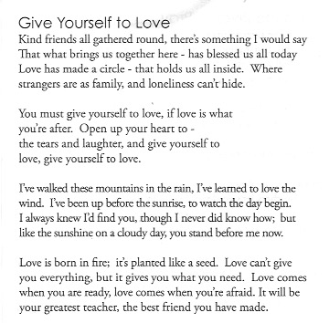

Dismissal
People: Thanks be to God.

