Nativity Worships

Advent 2020—Christmas Pageant

December 13

Episcopal Church of the Nativity
San Rafael, California

The Rev. Kirsten Snow Spalding, Rector

The Rev. Scott Sinclair, Assisting Priest

The Rev. Lynn Oldham Robinett, Assisting Priest

The Rev. Rebecca Morehouse, Deacon

10 a.m. Sunday Services will be Livestreamed on Facebook and may also be offered outside with COVID19 protocols, weather permitting.

Prelude Bach Prelude in D

Opening Hymn People Look East WLP 724

Candle Lighting Prayers

Everyone is invited to light their home advent wreathes.
All stand, and the Officiant greets the people with these words.
 | Light and peace, in Jesus Christ our Lord.
People | Thanks be to God.
Officiant
O Lord God Almighty, as you have taught us to call the evening, the morning, and the noonday one day; and have made the sun to know its going down: Dispel the darkness of
our hearts, that by your brightness we may know you to be the true God and eternal light, living and reigning for ever and ever. Amen.

The candles of the Advent wreath are lit, one for each week of Advent in the order—purple (or blue), purple, pink, purple.

Officiant
Dear People of God: In the season of Advent, it is our responsibility and joy to prepare ourselves to hear once more the message of the Angels, to go to Bethlehem and see the Son of God lying in a manger.

Let us hear and heed in Holy Scripture the story of God’s loving purpose from the time of our rebellion against him until the glorious redemption brought to us by his holy Child Jesus, and let us look forward to the yearly remembrance of his birth with hymns and songs of praise.

Opening Acclamation

Presider
Bles-sed are you, hol - y and liv - ing One.

People

You come to your people and set them free.

The people say together
Almighty God, to you all hearts are open, all desires known, and from you no secrets are hid: Cleanse the thoughts of our hearts by the inspiration of your Holy Spirit, that we may perfectly love you, and worthily magnify your holy Name; through Christ our God. Amen.

Kyrie S86

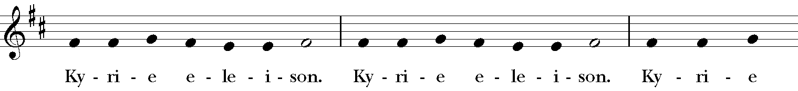
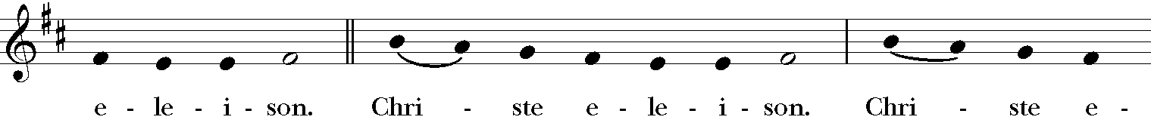
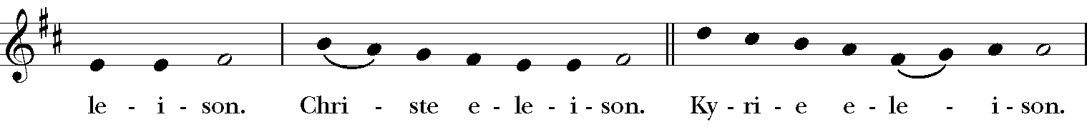
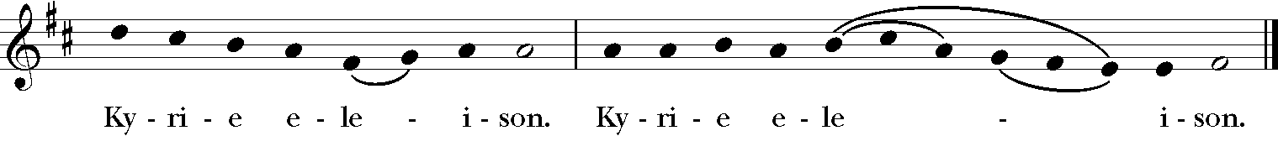

The Collect of the Day

The Presider says to the people
God be with you.
People And also with you.
Presider Let us pray.

The Presider says the Collect
Stir up your power, O Lord, and with great might come among us; and, because we are sorely hindered by our sins, let your bountiful grace and mercy speedily help and deliver us; through Jesus Christ our Lord, to whom, with you and the Holy Spirit, be honor and glory, now and for ever. Amen.
People Amen.

The Word of God

The Pageant Produced by Kim Bromley and Amanda Cairo

PAGEANT CAST:
Nancy Barnes - Reader. Luke
Alton Bender - Reader, Luke; Violin Silent Night
Rivers Bender - Reader, Luke; Violin Silent Night
Lucia Blake - Reader, Matthew
Seamus Blake - Reader, Matthew
Kim Bromley, Reader, Isaiah
Amanda Cairo - Reader, Luke; Dulcimer & Flute We Three Kings
Karen Henke - Reader, Matthew
Abbie Morehouse - Reader, Matthew & Luke; Vocals Away in a Manger
Angelina Parris - Reader, Matthew
Sebastian Parris - Reader, Matthew
Carl Robinett - Inn Keeper/VO (Inn scene); Vocals Hark the Herald Angels
Kelly Robinett - Reader, Matthew; Inn Keeper (Inn scene); Vocals Hark the Herald Angels
Phil Sandahl - Guitar & Vocals, Joseph’s Song
Emma Kenney-Saribalis - Sheep & Angel
Dylan Snodgrass - Piano & Vocals, Bring a Torch Jeanette Isabella
Madeleine Toby - Reader, Matthew
Brynlee Williams - Mary (Inn scene)

Joy to the World H100

The Nicene Creed (from Enriching our Worship)

All standing, the people say together
We believe in one God,
the Father, the Almighty,
maker of heaven and earth,
of all that is, seen and unseen.
We believe in one Lord, Jesus Christ,
the only Son of God,
eternally begotten of the Father,
God from God, Light from Light,
true God from true God,
begotten, not made,
of one Being with the Father,
through him all things were made.
For us and for our salvation
he came down from heaven,
was incarnate of the Holy Spirit and the Virgin Mary,
and became truly human.
For our sake he was crucified under Pontius Pilate;
he suffered death and was buried.
On the third day he rose again
in accordance with the Scriptures;
he ascended into heaven
and is seated at the right hand of the Father.
He will come again in glory to judge the living and the dead,
and his kingdom will have no end.
We believe in the Holy Spirit, the Lord, the giver of life,
who proceeds from the Father,
who with the Father and the Son is worshiped and glorified,
who has spoken through the prophets.
We believe in one holy catholic and apostolic Church.
We acknowledge one baptism for the forgiveness of sins.
We look for the resurrection of the dead,
and the life of the world to come. Amen.

The Prayers of the People

Prayer is offered with intercession for the universal church, its members, and its mission, the nation and all in authority, the welfare of the world, the concerns of the local community, those who suffer and those in any trouble, and all the departed.

We invite you to add your own prayers out loud, in the chat function of our livestream or silently, as the Spirit moves you.

Leader: In peace, faith, and the love of God, let us offer our prayers, responding to: "God of hope", with "Hear our prayer."
A period of silence is kept.
Grant, Almighty God, that all who confess your Name may be united in your truth, live together in your love, and reveal your glory in the world.
Silence
God of Hope, Hear our prayer.

Guide the people of this land, and of all the nations, in the ways of justice and peace; that we may honor one another and serve the common good.
Silence
God of Hope. Hear our prayer.

Give us all a reverence for the earth as your own creation, that we may use its resources rightly in the service of others and to your honor and glory.
Silence
God of Hope. Hear our prayer.

Bless all whose lives are closely linked with ours, remembering especially our parish members Carissa, Marge, Juliette, Mary, Dan, Donna, Jim, Leslie, Lynn, Jean and Norma and grant that we may serve Christ in them, and love one another as he loves us.
Silence
God of Hope. Hear our prayer.

Comfort and heal all those who suffer in body, mind, or spirit, remembering especially our friends and family Colton, Ellen, Katherine, Ed, Daniel, Marco, John, Thomas, Marg, Mary O, Mary P, Jill, Doug, Barbara, Nathaniel, Les, Polly, Linda, Sara, Kelly and Dennis and Bob; give them courage and hope in their troubles, and bring them the joy of your salvation.

Silence
God of Hope. Hear our prayer.

We commend to your mercy all who have died, remembering especially Herschel Snodgrass that your will for them may be fulfilled; and we pray that we may share with all your saints in your eternal kingdom.
Silence
God of Hope. Hear our prayer.

The Celebrant adds a concluding Collect.
Hasten, O God, the coming of your kingdom; and grant that we your servants who now live by faith, may with joy behold your son at his coming glorious majesty, even Jesus Christ our only Mediator and Advocate. Amen.

Confession of Sin
The Deacon or Presider says

Let us confess our sins to God.

Silence may be kept.

Minister and People
God of all mercy,
we confess that we have sinned against you,
opposing your will in our lives.
We have denied your goodness in each other,
in ourselves, and in the world you have created.
We repent of the evil that enslaves us,
the evil we have done,
and the evil done on our behalf.
Forgive, restore, and strengthen us
through our Savior Jesus Christ,
that we may abide in your love
and serve only your will. Amen.

Priest
Almighty God have mercy on you, forgive you all your sins
through the grace of Jesus Christ, strengthen you in all goodness,
and by the power of the Holy Spirit keep you in eternal life.
Amen.

The Peace

All stand. The Presider says to the people

The peace of Christ be always with you.
People And also with you.

Then the People may greet one another in the name of God in their families or through the chat function of our livestream.

Parish Announcements are made at this time.

An Advent Introduction to the Gospel of Mark
The Rev. Scott Gambrill Sinclair has been leading a four-week lecture and discussion series on Monday evenings during Advent. based on his book about the Gospel of Mark. Join Rev. Scott, via Zoom, from 7 to 8:30 pm. December 14. If you would like a copy of Rev. Scott's book and his lecture notes, they are available on our homepage. The Zoomlink is here:. Meeting ID: 89577326611.
The Street Chaplaincy Holiday Fundraiser. There is a $10K matching grant through December 24th. For more information see the link here.
Advent Octave. Evening Prayer with the O Antiphons. 5:30–6 p.m. each night on Facebook Livestream. The O Antiphons refer to the seven antiphons that are recited (or chanted) preceding the Magnificat during Evening Prayer. They cover the special of Advent preparation known as the Octave before Christmas Eve, Dec. 17–23, with Dec. 24 being Christmas Eve. (For more description of the O Antiphon see: More info on O Antiphons.

Zoom Coffee Hour. Join us for fellowship following worship today (and celebrate our Pageant participants!) The link is here.

Offering We will with thanksgiving receive offerings of Nativity pledges and plate today. You can contribute by sending a check to the church or by using the “Give” button on our website, www.nativityonthehill.org.

Communion All who participate in this Holy Eucharist virtually receive the full benefits of the sacrament by coming with the intention of being united with Christ and one another. (BCP 457).

The Holy Communion
The Presider begins the Offertory with a sentence of Scripture.

Offertory Sentence
I appeal to you brothers and sisters, by the mercies of God, to present yourselves as a living sacrifice, holy and acceptable to God, which is your spiritual worship. Romans 12:1

Offertory Hymn O Come, O Come Emmanuel H 56
The Great Thanksgiving

Gifts of pledge and other donations may be made by sending a check to the Church office, or by electronic payment using the “Give” button on the Nativity homepage (www.nativityonthehill.org).

The officiant, receiving the gifts of the people
All things come of you, O God.
People And of your own have we given you.

Then, facing the Holy Table, the Presider proceeds

Presider and People

Sanctus S124

Then the Presider continues
Glory and honor are yours, Creator of all,
your Word has never been silent;
you called a people to yourself, as a light to the nations,
you delivered them from bondage
and led them to a land of promise.
Of your grace, you gave Jesus
to be human, to share our life,
to proclaim the coming of your holy reign
and give himself for us, a fragrant offering.

Through Jesus Christ our Redeemer,
you have freed us from sin,
brought us into your life,
reconciled us to you,
and restored us to the glory you intend for us.

We thank you that on the night before he died for us
Jesus took bread,
and when he had given thanks to you, he broke it,
gave it to his friends and said:
“Take, eat, this is my Body, broken for you.
Do this for the remembrance of me.”

After supper Jesus took the cup of wine,
said the blessing, gave it to his friends and said:
“Drink this, all of you:
this cup is the new Covenant in my Blood,
poured out for you and for all
for the forgiveness of sin.
Do this for the remembrance of me.”

And so, remembering all that was done for us:
the cross, the tomb, the resurrection and ascension,
longing for Christ’s coming in glory,
and presenting to you these gifts
your earth has formed and human hands have made,
we acclaim you, O Christ:

Presider and People
Dying, you destroyed our death.
Rising, you restored our life.
Christ Jesus, come in glory!

The Presider continues
Send your Holy Spirit upon us
and upon these gifts of bread and wine
that they may be to us
the Body and Blood of your Christ.
Grant that we, burning with your Spirit’s power,
may be a people of hope, justice and love.

Giver of Life, draw us together in the Body of Christ,
and in the fullness of time gather us
with all your people
into the joy of our true eternal home.

Presider
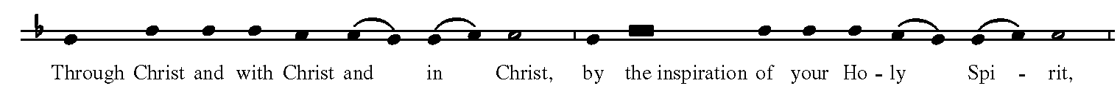
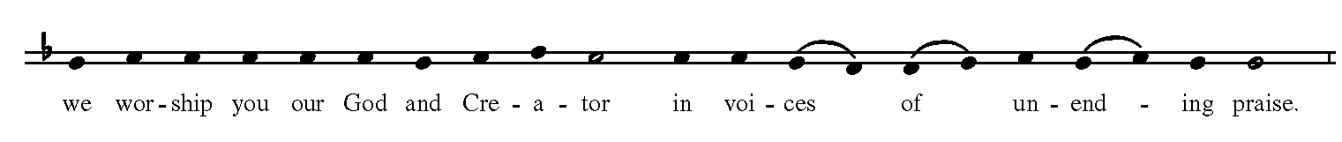
Presider and people
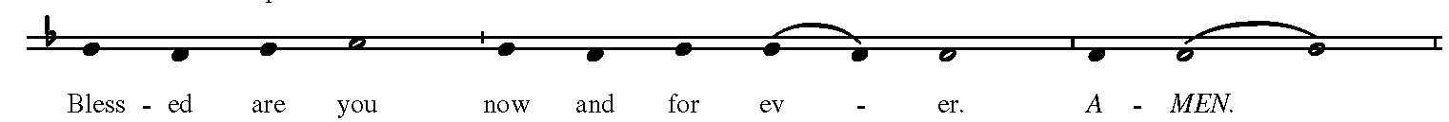

As our Savior Christ has taught us, we now pray,

People and Presider
Our Father in heaven,
hallowed be your Name,
your kingdom come,
your will be done,
on earth as in heaven.
Give us today our daily bread.
Forgive us our sins
as we forgive those
who sin against us.
Save us from the time of trial,
and deliver us from evil.
For the kingdom, the power,
and the glory are yours,
now and for ever. Amen

The Breaking of the Bread

The Presider breaks the consecrated Bread. A period of silence is kept. Then we sing,

Fraction Anthem: Lamb of God S161

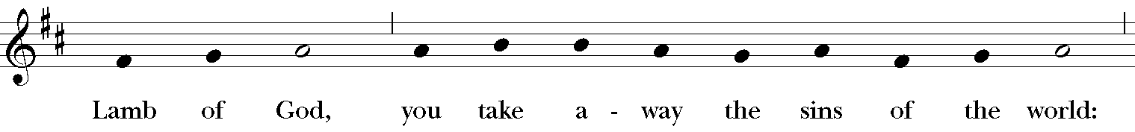
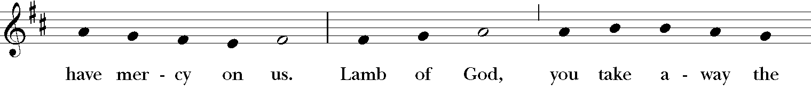

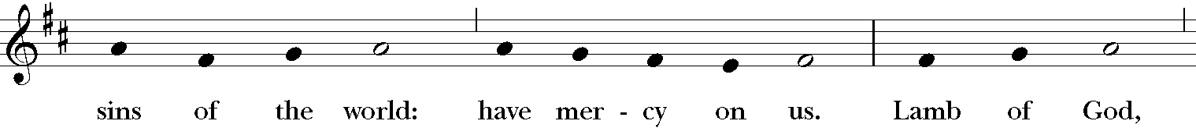
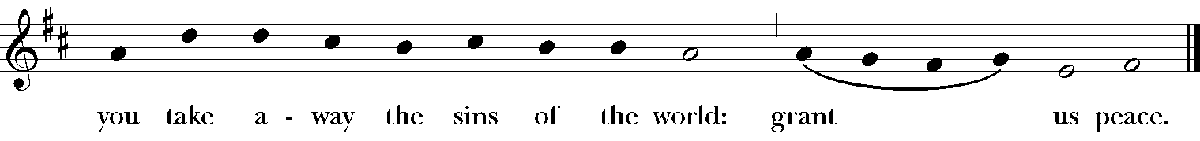

Facing the people, the Presider says the following Invitation
The Gifts of God for the People of God

Everyone who comes to virtual Communion with the intention of being united with Christ and one another receives the full benefit of Communion. The presider consumes the bread and wine with the following words:

The Body and Blood of our Savior keep us in everlasting life.

Post communion Prayer

After Communion, the People stand as they are able. The Presider says

Let us pray.

Presider and People
God of abundance,
you have fed us
with the bread of life and cup of salvation;
you have united us
with Christ and one another;
and you have made us one
with all your people in heaven and on earth.
Now send us forth
in the power of your Spirit,
that we may proclaim your redeeming love to the world
and continue for ever
in the risen life of Christ our Savior. Amen.

Advent Blessing
The People remain standing for the seasonal blessing and the people respond Amen! after each prayer.

The Priest
May Almighty God, by whose providence our Savior Christ came among us in great humility, sanctify you with the light of his blessing and set you free from all sin. Amen.

May he whose second Coming in power and great glory we await, make you steadfast in faith, joyful in hope, and constant in love. Amen.

May you, who rejoice in the first Advent of our Redeemer, at his second Advent be rewarded with unending life. Amen.

And the blessing of God Almighty, the Father, the Son, and the Holy Spirit, be upon you and remain with you forever. Amen.

Birthday Prayer
Our blessing prayer is: O God, our times are in your hand: Look with favor, we pray, on your servant N. as he begins another year. Grant that he may grow in wisdom and grace, and strengthen his trust in your goodness all the days of his life; through Jesus Christ our Lord. Amen.

Closing Hymn Tell Out My Soul H437

The Deacon, or the Presider, dismisses them and the People respond
Thanks be to God.

Postlude Chopin Prelude in G


Please connect with us by sending an email to nativityonthehill@gmail.com, calling the office and leaving a message at 415-479-7023, or sending a text or call to Rev. Kirsten at 510-207-6346. We look forward to hearing from you with any concerns, prayers or thanksgivings.

