Nativity Worships
The Season After Pentecost
Celebration of our Confirmands
Angelina Parris and Carl Robinett

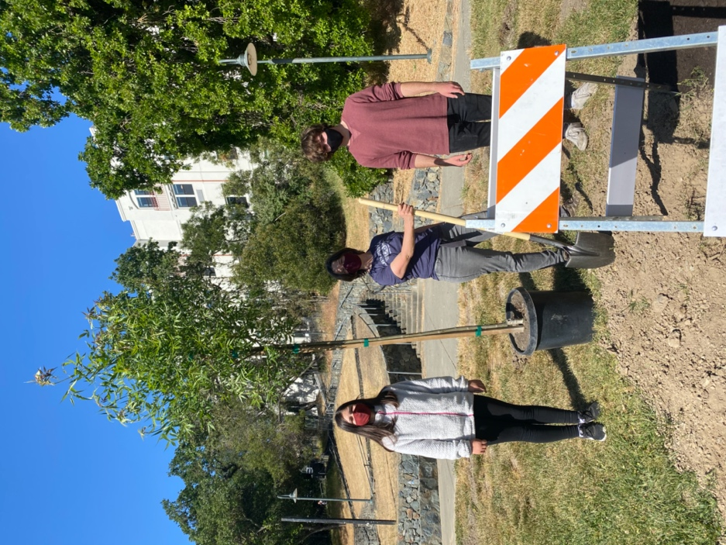

Sunday, June 6, 2021

The Rev. Kirsten Snow Spalding, Rector
The Rev. Rebecca Morehouse, Deacon
The Rev. Scott Gambrill Sinclair, Assisting Priest
The Rev. Lynn Oldham Robinett, Assisting Priest

The Word of God

PRELUDE Tree Song by Ken Medema
Dylan Snodgrass, Music Director, Angelina Parris, Clarinet, Carl Robinett, Tenor.

Entrance Rite

Entrance Hymn I want to walk as a child of the light (Houston) (H 490)

Opening Acclamation (BCP p. 355)
The people standing, the Celebrant says
 | Blessed be God: Father, Son, and Holy Spirit.
People | And blessed be his kingdom, now and for ever. Amen.

Collect for Purity (BCP p. 355)
The Celebrant may say
Almighty God, to you all hearts are open, all desires known, and from you no secrets are hid: Cleanse the thoughts of our hearts by the inspiration of your Holy Spirit, that we may perfectly love you, and worthily magnify your holy Name; through Christ our Lord. Amen.

Opening Anthem or Song of Praise S 277 Glory to God (Canticle 20) (Hurd) (BCP p. 356)
The following is sung, all standing

The Collect of the Day (BCP p. 357)
Celebrant | God be with you.
People | And also with you.
Celebrant | Let us pray.

O God, from whom all good proceeds: Grant that by your inspiration we may think those things that are right, and by your merciful guiding may do them; through Jesus Christ our Lord, who lives and reigns with you and the Holy Spirit, one God, for ever and ever. Amen.

Collect for Confirmands

O God, you prepared your disciples for the coming of the Spirit through the teaching of your Son Jesus Christ: Make the hearts and minds of your servants Angelina Parris and Carl Robinett ready to receive the blessing of the Holy Spirit, that they may be filled with the strength of his presence; through Jesus Christ our Lord. Amen.

The Lessons

First Reading: Genesis 3:8-15
The people sit.
A Reading from the book of Genesis.
⁸They heard the sound of the Lord God walking in the garden at the time of the evening breeze, and the man and his wife hid themselves from the presence of the Lord God among the trees of the garden. ⁹But the Lord God called to the man, and said to him, “Where are you?” ¹⁰He said, “I heard the sound of you in the garden, and I was afraid, because I was naked; and I hid myself.” ¹¹He said, “Who told you that you were naked? Have you eaten from the tree of which I commanded you not to eat?” ¹²The man said, “The woman whom you gave to be with me, she gave me fruit from the tree, and I ate.” ¹³Then the Lord God said to the woman, “What is this that you have done?” The woman said, “The serpent tricked me, and I ate.” ¹⁴The Lord God said to the serpent,
“Because you have done this,
cursed are you among all animals
and among all wild creatures;
upon your belly you shall go,
and dust you shall eat
all the days of your life.
¹⁵I will put enmity between you and the woman,
and between your offspring and hers;
he will strike your head,
and you will strike his heel.”

Reader | The Word of the Lord.
People | Thanks be to God.

Silence may follow.

Psalm: Psalm 130
Remain seated.
¹Out of the depths have I called to you, O Lord;
Lord, hear my voice; *
let your ears consider well the voice of my supplication.
²If you, Lord, were to note what is done amiss, *
O Lord, who could stand?
³For there is forgiveness with you; *
therefore you shall be feared.
⁴I wait for the Lord; my soul waits for him; *
in his word is my hope.
⁵My soul waits for the Lord,
more than watchmen for the morning, *
more than watchmen for the morning.
⁶O Israel, wait for the Lord, *
for with the Lord there is mercy;
⁷with him there is plenteous redemption, *
and he shall redeem Israel from all their sins.

Second Reading: 2 Corinthians 4:13--5:1
The people sit.
A Reading from Paul's Second letter to the Church in Corinth.
¹³Just as we have the same spirit of faith that is in accordance with scripture—”I believed, and so I spoke”—we also believe, and so we speak, ¹⁴because we know that the one who raised the Lord Jesus will raise us also with Jesus, and will bring us with you into his presence. ¹⁵Yes, everything is for your sake, so that grace, as it extends to more and more people, may increase thanksgiving, to the glory of God.
¹⁶So we do not lose heart. Even though our outer nature is wasting away, our inner nature is being renewed day by day. ¹⁷For this slight momentary affliction is preparing us for an eternal weight of glory beyond all measure, ¹⁸because we look not at what can be seen but at what cannot be seen; for what can be seen is temporary, but what cannot be seen is eternal.
^{5:1}For we know that if the earthly tent we live in is destroyed, we have a building from God, a house not made with hands, eternal in the heavens.

Reader | The Word of the Lord.
People | Thanks be to God.

Silence may follow.

Sequence Hymn WLP 848 Alleluia and verses (Hooker) (Gelobt sei Gott) (WLP 848)
All stand.

Gospel: Mark 3:20-35
All stand.
Deacon | The Holy Gospel of our Savior Jesus Christ according to Mark.
People | Glory to you, Lord Christ.

²⁰The crowd came together again, so that [Jesus and his disciples] could not even eat. ²¹When his family heard it, they went out to restrain him, for people were saying, “He has gone out of his mind.” ²²And the scribes who came down from Jerusalem said, “He has Beelzebul, and by the ruler of the demons he casts out demons.” ²³And he called them to him, and spoke to them in parables, “How can Satan cast out Satan? ²⁴If a kingdom is divided against itself, that kingdom cannot stand. ²⁵And if a house is divided against itself, that house will not be able to stand. ²⁶And if Satan has risen up against himself and is divided, he cannot stand, but his end has come. ²⁷But no one can enter a strong man’s house and plunder his property without first tying up the strong man; then indeed the house can be plundered.
²⁸“Truly I tell you, people will be forgiven for their sins and whatever blasphemies they utter; ²⁹but whoever blasphemes against the Holy Spirit can never have forgiveness, but is guilty of an eternal sin”—³⁰for they had said, “He has an unclean spirit.”
³¹Then his mother and his brothers came; and standing outside, they sent to him and called him. ³²A crowd was sitting around him; and they said to him, “Your mother and your brothers and sisters are outside, asking for you.” ³³And he replied, “Who are my mother and my brothers?” ³⁴And looking at those who sat around him, he said, “Here are my mother and my brothers! ³⁵Whoever does the will of God is my brother and sister and mother.”

Deacon | The Gospel of our Savior.
People | Praise to you, Lord Christ.

The Sermon AND REFLECTIONS The Rev. Kirsten Snow Spalding
Angelina Parris and Carl Robinett

The Creed (BCP p. 358)
All stand.
We believe in one God,
the Father, the Almighty,
maker of heaven and earth,
of all that is, seen and unseen.
We believe in one Lord, Jesus Christ,
the only Son of God,
eternally begotten of the Father,
God from God, Light from Light,
true God from true God,
begotten, not made,
of one Being with the Father;
through him all things were made.
For us and for our salvation
he came down from heaven,
was incarnate of the Holy Spirit and the Virgin Mary
and became truly human.
For our sake he was crucified under Pontius Pilate;
he suffered death and was buried.
On the third day he rose again
in accordance with the Scriptures;
he ascended into heaven
and is seated at the right hand of the Father.
He will come again in glory to judge the living and the dead,
and his kingdom will have no end.
We believe in the Holy Spirit, the Lord, the giver of life,
who proceeds from the Father [and the Son],
who with the Father and the Son is worshiped and glorified,
who has spoken through the prophets.
We believe in one holy catholic and apostolic Church.
We acknowledge one baptism for the forgiveness of sins.
We look for the resurrection of the dead,
and the life of the world to come. Amen.

The Prayers of the People (BCP p. 359)
All remain standing.
I ask your prayers for God’s people throughout the world; for our Bishop Michael, for our Diocesan Bishop Marc, for our clergy, Kirsten, Rebecca, Scott and Lynn; for this gathering; and for all ministers and people.
Pray for the Church.
Silence
I ask your prayers for peace; for goodwill among nations; and for the well-being of all people.
Pray for justice and peace.
Silence
I ask your prayers for the poor, the sick, the hungry, the oppressed, and those in prison.
Pray for those in any need or trouble.
Silence
I ask your prayers for all who seek God, or a deeper knowledge of him.
Pray that they may find and be found by him.
Silence
I ask your prayers for the departed especially Mary O’Dell and Helen Biggers.
Pray for those who have died.
Silence
Members of the congregation may ask the prayers or the thanksgivings of those present
I ask your prayers for our parish members: Carissa, Marge, Juliette, Mary A, Dan, Donna, Jim, Leslie, Duane, Norma, Steve, Nancy and for our friends and family, Katherine, Ed, John brother of Gail S, Mary P, Nathaniel brother of Rebecca, Les, Eric and Julie, Ronald and Emily, Bob, Tony, Polly and Sylvia; and grant that we may serve Christ in them, and love one another as he loves us.
I ask your thanksgiving for Carl and Angelina, for their parents, Godparents and all who have supported them in their journey of faith.
Silence
The Celebrant adds a concluding Collect.

LITURGY OF PREPARATION for Confirmands

The parents and godparents present the confirmands to the Celebrant with these words:

We present to you Carl and Angelina who have been growing in an understanding of their call as Christians among us and now desire to undertake a mature affirmation of their baptismal covenant in the rite of confirmation.

Celebrant Have they studied the promises made at their baptism and strived to keep them in fellowship with this community and the rest of the Church?

Sponsors They have.

Celebrant Have they attended worship regularly to hear God’s word and to celebrate the mystery of Christ’s dying and rising?

Sponsors They have.

Celebrant Have they participated in a life of service to those who are poor, outcast, or powerless?

Sponsors They have.

Celebrant Have they strived to recognize the gifts that God has given them and to discern how they are to be used in the building up of God’s reign of peace and justice?

Sponsors They have.

Celebrant (to the baptized) Will you strive to set an example for us of that turning towards Jesus Christ which marks true conversion?

Confirmands We will with God’s help.

Celebrant (to the sponsors) Will you accompany these candidates in their journey to conversion and help them to renew their commitment to Christ?

Sponsors We will with God’s help.

In full view of the congregation those enrolled kneel or bow their heads. Their sponsors stand behind them and place a hand on their shoulders.

Celebrant Blessed are you, our God, our Maker, for you faithfully call us to return to you and do not abandon us to our own selfishness. You have given Carl and Angelina to us as examples of our reliance on you. Renew your Holy Spirit in them that they may lead us in our turning back to you as they prepare to renew their Baptismal promises and commit themselves to Christ, who lives and reigns with you and the Holy Spirit, one God, now and for ever. Amen.

Presentation of Letters from Sponsors
Each set of parents and godparents present letters to their confirmand.

Sponsors We present to you, Angelina, these letters of encouragement and affirmation as signs of our commitment to support you in your continuing journey of faith.

Sponsors We present to you, Carl, these letters of encouragement and affirmation as signs of our commitment to support you in your continuing journey of faith.

The Peace (BCP p. 360)
All stand.
Celebrant | The peace of the Lord be always with you.
People | And also with you.

Then the Ministers and the People may greet one another in the name of the Lord.

Announcements
Altar Flowers are given today by Kim Bromley in thanksgiving for our confirmands, Angelina Parris and Carl Robinett.

Bible Study meets on the 2nd and 4th Thursdays at 10:30 a.m., via Zoom.

Calling 2021 Graduates: If you have someone in your family who is graduating from any grade (or University) this spring, please send a note to nativityonthehill@gmail.com.. Like last year, we will gather pictures of graduates and make donations to their favorite charities. We will celebrate our graduates with a special blessing on June 13th.
Zoom Coffee Hour following our service this morning can be joined at this link: https://us02web.zoom.us/j/931317924

We will with thanksgiving receive offerings of Nativity pledges and plate today. You can contribute by sending a check to the church or by using the "Give" button on our website, www.nativityonthehill.org.

All who participate in this Holy Eucharist virtually receive the full benefits of the sacrament by coming with the intention of being united with Christ and one another. (BCP 457).

The Holy Communion

Offertory Sentence (BCP p. 376)
The Celebrant says
Walk in love, as Christ loved us and gave himself for us, an offering and sacrifice to God. Ephesians 5:2

Offertory Hymn I want to walk as a child of the light (Houston) (H 490)
The Great Thanksgiving

The People remain standing.

Proper Preface
Celebrant It is truly right, and good and joyful, to give you thanks, all-holy God, source of life and fountain of mercy. You have filled us and all creation with your blessing and fed us with your constant love; you have redeemed us in Jesus Christ and knit us into one body. Through your Spirit you replenish us and call us to fullness of life. Therefore, joining with Angels and Archangels and with the faithful of every generation, we lift our voices with all creation as we sing (say):

Sanctus WLP 858 Holy, holy, holy (Folk/Pruner) (American folk melody)
Celebrant and People
Words of Institution
The Celebrant continues
Blessed are you, gracious God, creator of the universe and giver of life. You formed us in your own image and called us to dwell in your infinite love.

You gave the world into our care that we might be your faithful stewards
and show forth your bountiful grace. But we failed to honor your image
in one another and in ourselves; we would not see your goodness in the world around us;
and so we violated your creation, abused one another, and rejected your love.

Yet you never ceased to care for us, and prepared the way of salvation for all people.
Through Abraham and Sarah you called us into covenant with you.

You delivered us from slavery, sustained us in the wilderness,
and raised up prophets to renew your promise of salvation.

Then, in the fullness of time, you sent your eternal Word,
made mortal flesh in Jesus. Born into the human family, and dwelling among us,
he revealed your glory. Giving himself freely to death on the cross, he triumphed over evil,
opening the way of freedom and life.

On the night before he died for us,
Our Savior Jesus Christ took bread, and when he had given thanks to you,
he broke it, and gave it to his friends, and said: “Take, eat: This is my Body which is given for you. Do this for the remembrance of me.”

As supper was ending, Jesus took the cup of wine, and when he had given thanks,
he gave it to them, and said: “Drink this, all of you: This is my Blood of the new Covenant,
which is poured out for you and for all for the forgiveness of sins.
Whenever you drink it, do this for the remembrance of me.”

Therefore we proclaim the mystery of faith:
Celebrant and People
Christ has died.
Christ is risen.
Christ will come again.

Epiclesis
The Celebrant continues
Remembering his death and resurrection, we now present to you from your creation
this bread and this wine.
By your Holy Spirit may they be for us the Body and Blood of our Savior Jesus Christ.
Grant that we who share these gifts may be filled with the Holy Spirit and live as Christ’s Body in the world.
Bring us into the everlasting heritage of your daughters and sons, that with all your saints,
past, present, and yet to come, we may praise your Name for ever.

Through Christ and with Christ and in Christ, in the unity of the Holy Spirit,
to you be honor, glory, and praise, for ever and ever. AMEN

The Lord’s Prayer (BCP p. 363)
As our Savior Christ has taught us, we now pray,
People and Celebrant
Our Father in heaven,
hallowed be your Name,
your kingdom come,
your will be done, on earth as in heaven.
Give us today our daily bread.
Forgive us our sins
as we forgive those who sin against us.
Save us from the time of trial
and deliver us from evil.
For the kingdom, the power,
and the glory are yours,
now and forever. Amen.

The Breaking of the Bread

Fraction Anthem
Invitation (BCP p. 364)
The Celebrant says
The Gifts of God for the People of God.

Distribution (BCP p. 365)
The ministers receive the Sacrament in both kinds, and then immediately deliver it to the people.
The Bread and the Cup are given to the communicants with these words
The Body of Christ, the bread of heaven. [Amen.]
The Blood of Christ, the cup of salvation. [Amen.]

Communion Hymn Sweet, Sweet Spirit (LEVAS 120)
Post-Communion Prayer (BCP p. 365)
After Communion, the Celebrant says
Let us pray.
Celebrant and People
Eternal God, heavenly Father,
you have graciously accepted us as living members
of your Son our Savior Jesus Christ,
and you have fed us with spiritual food
in the Sacrament of his Body and Blood.
Send us now into the world in peace,
and grant us strength and courage
to love and serve you
with gladness and singleness of heart;
through Christ our Lord. Amen.

Blessing (BCP p. 366)
The Priest blesses the people, saying
The Wisdom of God
the Love of God
and the Grace of God
strengthen you
to be Christ’s hands and heart in this world,
in the name of the Holy Trinity. Amen.
(source: Celtic)

Birthday Blessing
O God, our times are in your hand: Look with favor, we pray, on your servant N. as he begins another year. Grant that he may grow in wisdom and grace, and strengthen his trust in your goodness all the days of his life; through Jesus
Christ our Lord. Amen.

Post-Communion Hymn Come, Holy Spirit, heavenly Dove (Saint Agnes) (H 510)
Dismissal (BCP p. 366)
 | Let us go forth into the world, rejoicing in the power of the Spirit.
People | Thanks be to God.

Postlude “Prelude” by Chopin

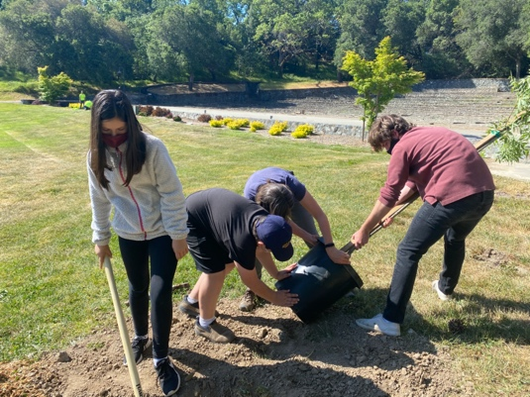
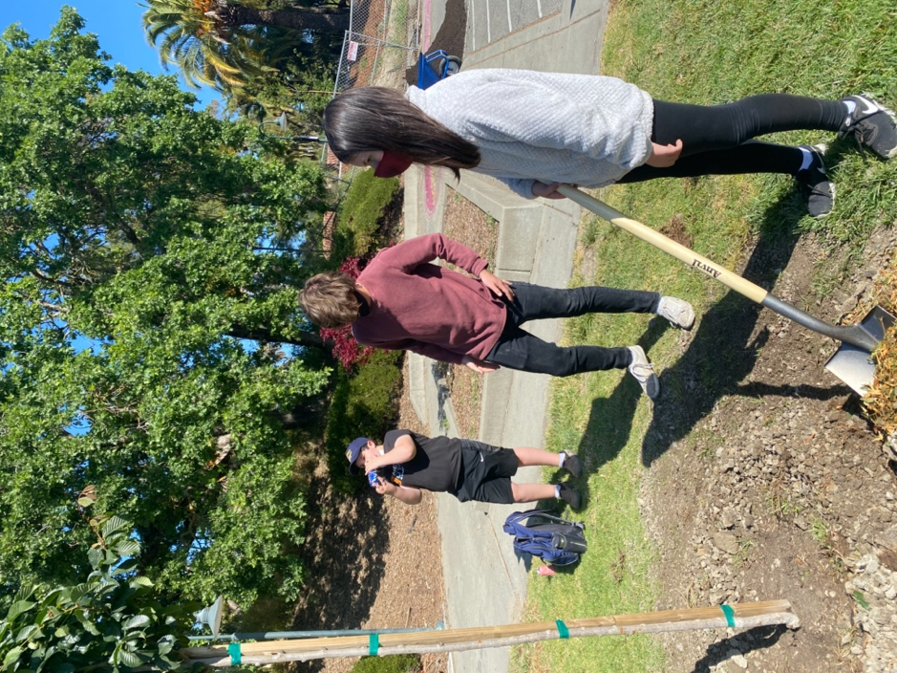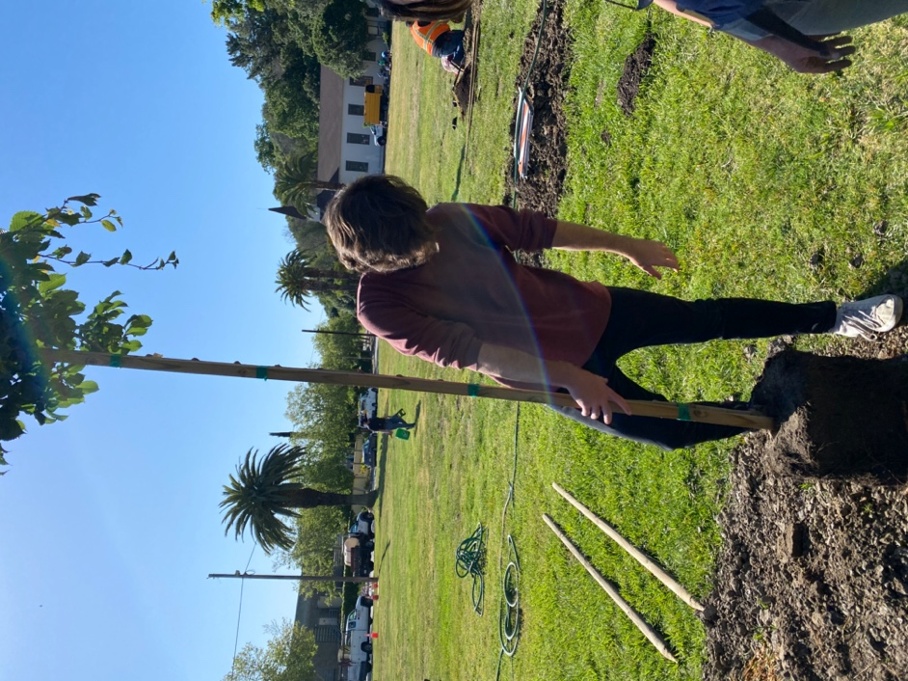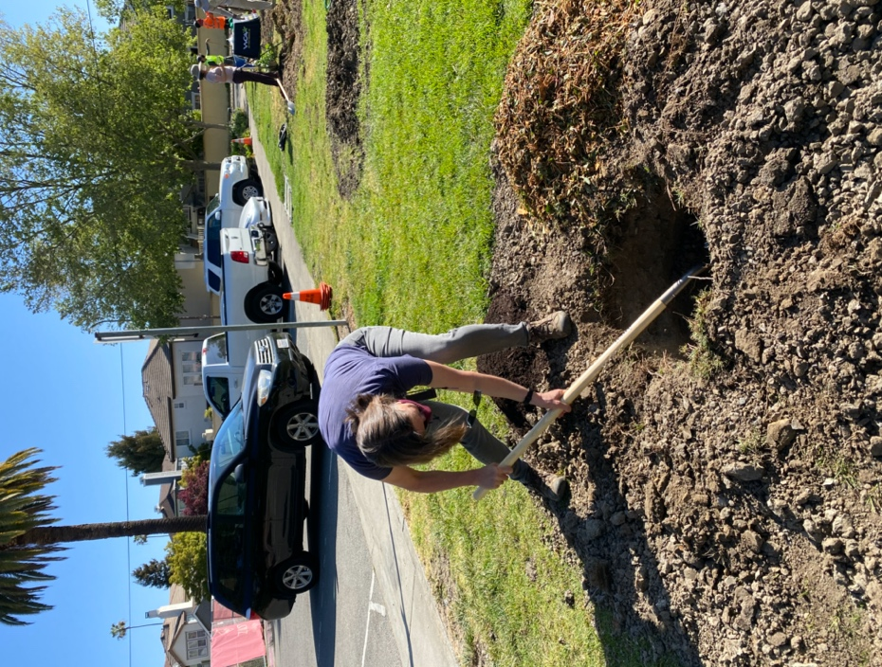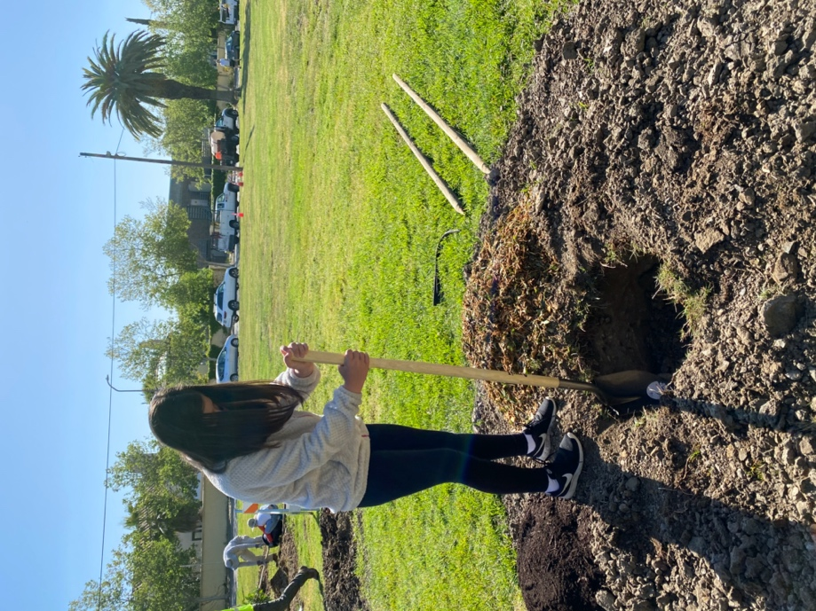

From riteplanning.com.
Copyright © 2021 Church Publishing Inc. All rights reserved.

