Candlelight Christmas Eve

December 24, 2021, 5 p.m.

Episcopal Church of the Nativity
San Rafael, California
The church on the hill in Lucas Valley

Merry Christmas and Peace to you!

The Rev. Kirsten Snow Spalding, Rector
The Rev. Scott Sinclair, Assisting Priest
The Rev. Lynn Oldham Robinett, Assisting Priest
The Rev. Rebecca Morehouse, Deacon

Our service this evening begins in the candlelit church. We invite you to gather with us in quiet contemplation. If you are joining us on facebook live, begin by lighting your own candles and coming together for a moment of silent prayer.

Prelude Intermezzo by Brahms
Dylan Snodgrass, Music Director

The Word of God

Entrance Rite

Entrance Hymn O come, all ye faithful (Adeste fideles) (H 83)
Opening Acclamation
The people standing, the Celebrant says
 | Blessed be God: Father, Son, and Holy Spirit.
People | And blessed be his kingdom, now and for ever. Amen.

Collect for Purity
The Celebrant may say
Almighty God, to you all hearts are open, all desires known, and from you no secrets are hid: Cleanse the thoughts of our hearts by the inspiration of your Holy Spirit, that we may perfectly love you, and worthily magnify your holy Name; through Christ our Lord. Amen.

Opening Song of Praise Once in Royal David’s City H102
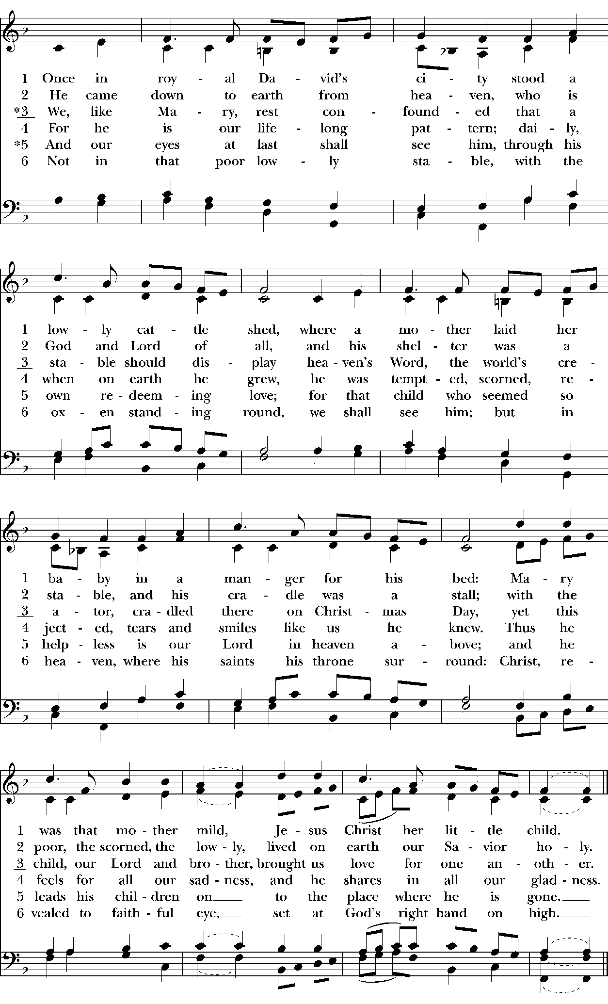

The Collect of the Day
Celebrant | God be with you.
People | And also with you.
Celebrant | Let us pray.

O God, you have caused this holy night to shine with the brightness of the true Light: Grant that we, who have known the mystery of that Light on earth, may also enjoy him perfectly in heaven; where with you and the Holy Spirit he lives and reigns, one God, in glory everlasting. Amen.
The Lessons

First Reading: Isaiah 9:2-7
The people sit.
A Reading from the book of the prophet Isaiah.
²The people who walked in darkness
have seen a great light;
those who lived in a land of deep darkness—
on them light has shined.
³You have multiplied the nation,
you have increased its joy;
they rejoice before you
as with joy at the harvest,
as people exult when dividing plunder.
⁴For the yoke of their burden,
and the bar across their shoulders,
the rod of their oppressor,
you have broken as on the day of Midian.
⁵For all the boots of the tramping warriors
and all the garments rolled in blood
shall be burned as fuel for the fire.
⁶For a child has been born for us,
a son given to us;
authority rests upon his shoulders;
and he is named
Wonderful Counselor, Mighty God,
Everlasting Father, Prince of Peace.
⁷His authority shall grow continually,
and there shall be endless peace
for the throne of David and his kingdom.
He will establish and uphold it
with justice and with righteousness
from this time onward and forevermore.
The zeal of the Lord of hosts will do this.

Reader | The Word of the Lord.
People | Thanks be to God.

Silence may follow.

Psalm: Psalm 96
Remain seated.
¹Sing to the Lord a new song; *
sing to the Lord, all the whole earth.
²Sing to the Lord and bless his Name; *
proclaim the good news of his salvation from day to day.
³Declare his glory among the nations *
and his wonders among all peoples.
⁴For great is the Lord and greatly to be praised; *
he is more to be feared than all gods.
⁵As for all the gods of the nations, they are but idols; *
but it is the Lord who made the heavens.
⁶Oh, the majesty and magnificence of his presence! *
Oh, the power and the splendor of his sanctuary!
⁷Ascribe to the Lord, you families of the peoples; *
ascribe to the Lord honor and power.
⁸Ascribe to the Lord the honor due his Name; *
bring offerings and come into his courts.
⁹Worship the Lord in the beauty of holiness; *
let the whole earth tremble before him.
¹⁰Tell it out among the nations: “The Lord is King! *
He has made the world so firm that it cannot be moved;
he will judge the peoples with equity.”
¹¹Let the heavens rejoice, and let the earth be glad;
let the sea thunder and all that is in it; *
let the field be joyful and all that is therein.
¹²Then shall all the trees of the wood shout for joy
before the Lord when he comes, *
when he comes to judge the earth.
¹³He will judge the world with righteousness *
and the peoples with his truth.

Second Reading: Titus 2:11-14
The people sit.
A Reading from Paul's letter to Titus.
¹¹The grace of God has appeared, bringing salvation to all, ¹²training us to renounce impiety and worldly passions, and in the present age to live lives that are self-controlled, upright, and godly, ¹³while we wait for the blessed hope and the manifestation of the glory of our great God and Savior, Jesus Christ. ¹⁴He it is who gave himself for us that he might redeem us from all iniquity and purify for himself a people of his own who are zealous for good deeds.

Reader | The Word of the Lord.
People | Thanks be to God.

Silence may follow.

Sequence Hymn While shepherds watched their flocks by night (Winchester Old) (H 94)
All stand.

Gospel: Luke 2:1-14
All stand.
Deacon | The Holy Gospel of our Lord Jesus Christ according to Luke.
People | Glory to you, Lord Christ.

¹In those days a decree went out from Emperor Augustus that all the world should be registered. ²This was the first registration and was taken while Quirinius was governor of Syria. ³All went to their own towns to be registered. ⁴Joseph also went from the town of Nazareth in Galilee to Judea, to the city of David called Bethlehem, because he was descended from the house and family of David. ⁵He went to be registered with Mary, to whom he was engaged and who was expecting a child. ⁶While they were there, the time came for her to deliver her child. ⁷And she gave birth to her firstborn son and wrapped him in bands of cloth, and laid him in a manger, because there was no place for them in the inn.
⁸In that region there were shepherds living in the fields, keeping watch over their flock by night. ⁹Then an angel of the Lord stood before them, and the glory of the Lord shone around them, and they were terrified. ¹⁰But the angel said to them, “Do not be afraid; for see—I am bringing you good news of great joy for all the people: ¹¹to you is born this day in the city of David a Savior, who is the Messiah, the Lord. ¹²This will be a sign for you: you will find a child wrapped in bands of cloth and lying in a manger.” ¹³And suddenly there was with the angel a multitude of the heavenly host, praising God and saying,
¹⁴“Glory to God in the highest heaven,
and on earth peace among those whom he favors!”
Deacon | The Gospel of the Lord.
People | Praise to you, Lord Christ.

Christmas Meditation The Rev. Kirsten Snow Spalding

Hymn It came upon the midnight clear (Carol) (H 89)

The Creed
All stand.
We believe in one God,
the Father, the Almighty,
maker of heaven and earth,
of all that is, seen and unseen.
We believe in one Lord, Jesus Christ,
the only Son of God,
eternally begotten of the Father,
God from God, Light from Light,
true God from true God,
begotten, not made,
of one Being with the Father.
Through him all things were made.
For us and for our salvation
he came down from heaven:
by the power of the Holy Spirit
he became incarnate from the Virgin Mary,
and was made man.
For our sake he was crucified under Pontius Pilate;
he suffered death and was buried.
On the third day he rose again
in accordance with the Scriptures;
he ascended into heaven
and is seated at the right hand of the Father.
He will come again in glory to judge the living and the dead,
and his kingdom will have no end.
We believe in the Holy Spirit, the Lord, the giver of life,
who proceeds from the Father and the Son.
With the Father and the Son he is worshiped and glorified.
He has spoken through the Prophets.
We believe in one holy catholic and apostolic Church.
We acknowledge one baptism for the forgiveness of sins.
We look for the resurrection of the dead,
and the life of the world to come. Amen.

The Prayers of the People
All remain standing.
Rejoicing in God’s gift of gentle grace, let us pray for the church, the world, and all on whom the light of Christ shines.

A brief silence.

Wonderful Counselor, you increase our joy as the church gathers on this holy night to sing of your presence among us. May the story of salvation live in the hearts of all who sing its wonders. God of light,

Hear our prayer.

Mighty God, you broke the yoke of sin’s burden through the birth of your Son. Comfort those whose burdens distract them from the deeper peace of this holy night and grant them a restful mind. God of light,

Hear our prayer.

Everlasting Father, uphold all who are in sorrow or in need of your divine goodness and mercy, especially our members: Carissa, Marge, Juliette, Dan, Donna, Jim, Duane, Norma, Steve, Nancy, Jamie, and Margaret D And our families, friends, and neighbors; remembering especially: Katherine, Ed, John, Mary P., Les, Eric and Julie, Ronald and Emily, Polly, Sylvia, Robert B, Linda, Sarah, Rachelle, Abbey, Diane B, Ed M, Janet L., Jared, Denise Gina, Bill, Miles, Laurie, and Jan W. God of light,

Hear our prayer.

Prince of Peace, may your reign be known in all places of violence and unrest and grant resolution to conflicts throughout the world. And we remember with thanksgiving all who have died and who now rest in your peaceful light. Pray for their souls and comfort for their families.
God of light,

Hear our prayer.

Here other intercessions may be offered, either silently or aloud.

Silence

God of light,

Hear our prayer.

Lord Jesus Christ, you were born to bring light, healing, peace, and justice into the world. Hear now our prayers and hasten the coming of your Heavenly Kingdom where with the Father and Holy Spirit, you live and reign, now and for ever. Amen.
The Peace
All stand.
Celebrant | The peace of the Lord be always with you.
People | And also with you.
Then the Ministers and the People may greet one another in the name of the Lord.
Announcements

December 25 Christmas Day service at 10 a.m. In person and livestreamed on Facebook.

December 26 Quiet Holy Eucharist 10 a.m. In person and livestreamed on Facebook.

January 2nd Christmas Festival of Lessons and Carols (no Eucharist), in person and livestreamed on Facebook.

Offering We will with thanksgiving receive offerings of Nativity pledges and plate today. You can contribute by sending a check to the church or by using the “Give” button on our website, www.nativityonthehill.org.

Communion All who participate in this Holy Eucharist virtually receive the full benefits of the sacrament by coming with the intention of being united with Christ and one another. (BCP 457).

The Holy Communion

Offertory Sentence
The Celebrant says
Offer to God a sacrifice of thanksgiving, and make good your vows to the Most High. Psalm 50:14

Anthem Twas in the Moon of Wintertime Jean de Breboeuf, Lyrics
French folk Melody (16th c.)

Anthem Sussex Carol Arr. David Willcocks
Nativity Festival Choir, Directed by Fred Goff, Accompanied by Dylan Snodgrass

The Great Thanksgiving

Sursum Corda
The People remain standing.
Presider | The Lord be with you.
People | And also with you.
Presider | Lift up your hearts.
People | We lift them to the Lord.
Presider | Let us give thanks to the Lord our God.
People | It is right to give our thanks and praise.

Proper Preface
Presider
All thanks and praise are yours at all times and in all places, our true and loving God; through Jesus Christ, your eternal Word, the Wisdom from on high by whom you created all things.
You laid the foundations of the world and enclosed the sea when it burst out from the womb;
You brought forth all creatures of the earth and gave breath to humankind.

Wondrous are you, Holy One of Blessing, all you create is a sign of hope for our journey;
And so as the morning stars sing your praises we join the heavenly beings and all creation as we shout with joy:

Sanctus S 125 Holy, holy, holy (Proulx)
Presider and People
Words of Institution
The Presider continues
Glory and honor are yours, Creator of all, your Word has never been silent;
you called a people to yourself, as a light to the nations, you delivered them from bondage
and led them to a land of promise. Of your grace, you gave Jesus to be human, to share our life, to proclaim the coming of your holy reign and give himself for us, a fragrant offering.

Through Jesus Christ our Redeemer, you have freed us from sin, brought us into your life,
reconciled us to you, and restored us to the glory you intend for us.
We thank you that on the night before he died for us Jesus took bread, and when he had given thanks to you, he broke it, gave it to his friends and said: “Take, eat, this is my Body, broken for you. Do this for the remembrance of me.”

After supper Jesus took the cup of wine, said the blessing, gave it to his friends and said: “Drink this, all of you: this cup is the new Covenant in my Blood, poured out for you and for all
for the forgiveness of sin. Do this for the remembrance of me.”

And so, remembering all that was done for us: the cross, the tomb, the resurrection and ascension, longing for Christ’s coming in glory, and presenting to you these gifts
your earth has formed and human hands have made, we acclaim you, O Christ:
Presider and People
Dying, you destroyed our death.
Rising, you restored our life.
Christ Jesus, come in glory!

Epiclesis
The Presider continues
Send your Holy Spirit upon us and upon these gifts of bread and wine
that they may be to us the Body and Blood of your Christ.
Grant that we, burning with your Spirit’s power, may be a people of hope, justice and love.
Giver of Life, draw us together in the Body of Christ, and in the fullness of time gather us with blessed Mary and Joseph, and all your people into the joy of our true eternal home.

Through Christ and with Christ and in Christ, by the inspiration of your Holy Spirit, we worship you our God and Creator in voices of unending praise.
Presider and People
Blessed are you now and for ever. AMEN.

The Lord’s Prayer (BCP p. 363)
As our Savior Christ has taught us, we now pray,
People and Celebrant
Our Father in heaven,
hallowed be your Name,
your kingdom come,
your will be done, on earth as in heaven.
Give us today our daily bread.
Forgive us our sins
as we forgive those who sin against us.
Save us from the time of trial
and deliver us from evil.
For the kingdom, the power,
and the glory are yours,
now and forever. Amen.

The Breaking of the Bread

Fraction Anthem Love came down at Christmas (Gartan) (h 84)
Invitation
The Celebrant says
The Gifts of God for the People of God.

Distribution
All are welcome to participate in Holy Eucharist at today’s service. We will make one line up the center aisle to receive communion and you may then go back to your seats via the outer aisles to avoid crowding those who are waiting for communion.

The Body and Blood of our Lord Jesus Christ keep you in everlasting life. [Amen.]

Communion Hymn Away in a manger, no crib for his bed (Cradle Song) ( H 101)

After Communion, the lights dim and candles are lit from the Christ candle and passed between us. If you are joining us by livestream consider putting a candle in your window this evening, sharing with your neighbors this symbol of Christ coming into the world.

Post Communion Hymn Silent night, holy night (Stille Nacht) (h 111)
Post-Communion Prayer
After Communion, the Celebrant says
Let us pray.
Celebrant and People
Eternal God, heavenly Father,
you have graciously accepted us as living members
of your Son our Savior Jesus Christ,
and you have fed us with spiritual food
in the Sacrament of his Body and Blood.
Send us now into the world in peace,
and grant us strength and courage
to love and serve you
with gladness and singleness of heart;
through Christ our Lord. Amen.

Blessing
The Priest blesses the people, saying
The blessing of God Almighty, the Father, the Son, and the Holy Spirit, be upon you and remain with you for ever. Amen.

Post-Communion Hymn Hark! the herald angels sing (Mendelssohn) (H 87)
Dismissal

 | Let us go forth in the name of Christ.
People | Thanks be to God.

POSTLUDE Christmas by Tchaikovsky

Special thanks to our Festival Choir, our Guest Choir Director, Fred Goff, our Music Director, Dylan Snodgrass for their contributions for this service and to the Altar Guild for making the sanctuary beautiful for our in-person and livestreamed worship.

Christmas Greens and Pointsettias were given by:

Gail Sanfilippo Duane Johnson Kathy Schlegel
Diana Singer Rev. Rebecca Morehouse Ruth Baney
Jane Hassinger

From riteplanning.com.
Copyright © 2020 Church Publishing Inc. All rights reserved.

