Liturgy for the Dedication and Consecration
of the
Nativity Memorial Wall and Garden
November 6, 2022

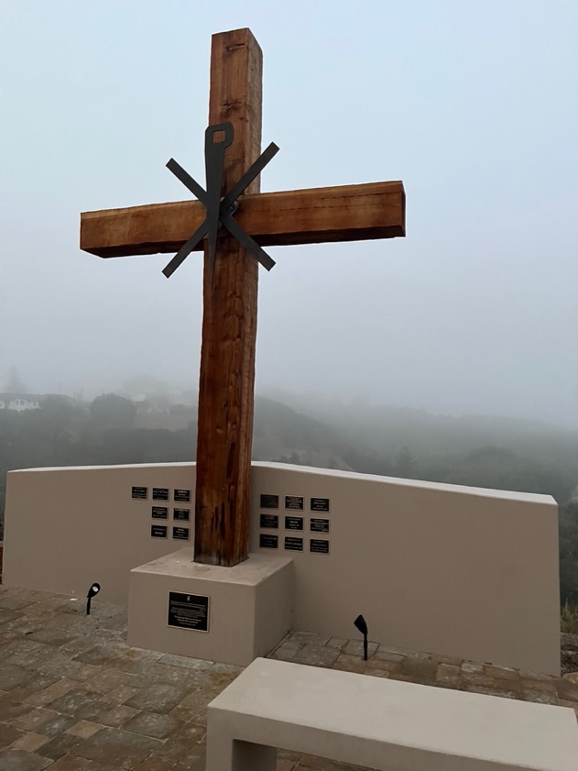
The Kirsten Snow Spalding, Rector
The Rev. Scott Gambrill Sinclair, Priest in Residence
The Rev. Lynn Oldham Robinett, Assistant Priest
The Rev. Rebecca Morehouse, Deacon

333 Ellen Drive
San Rafael, CA 94903
www.nativityonthehill.org
415-479-7023
The clergy and people gather after the dismissal and postlude at the back of the church to go in procession to the Memorial Wall and Garden.
When all are ready, the Priest says the following or similar words
Through the ages, Almighty God has moved his people to build places of prayer and praise, and to set apart places for the ministry of his holy Word and Sacraments. With gratitude for the rebuilding of our outdoor cross, and the building of the Memorial Wall, the benches and new altar at the Church of the Nativity, we are now gathered to dedicate and consecrate this Memorial Wall and Garden in God's Name.
Let us pray.
Almighty God, we thank you for making us in your image, to share in the ordering of your world. Receive the work of our hands in this place, now to be set apart for your worship, the building up of the living, and the remembrance of the dead,
to the praise and glory of your Name; through Jesus Christ our Lord. Amen.
When all have gathered at the Memorial Wall and Garden we will say together Psalm 121.
121 Levavi oculos

1 I lift up my eyes to the hills; *
from where is my help to come?

2 My help comes from the LORD, *
the maker of heaven and earth.

3 He will not let your foot be moved *
and he who watches over you will not fall asleep.

4 Behold, he who keeps watch over Israel *
shall neither slumber nor sleep;

5 The LORD himself watches over you; *
the LORD is your shade at your right hand,
6 So that the sun shall not strike you by day, *
nor the moon by night.

7 The LORD shall preserve you from all evil; *
it is he who shall keep you safe.

8 The LORD shall watch over your going out and your coming in, *
from this time forth for evermore.
The Officiant marks the Memorial Wall with the sign of the cross saying
Peace be to this place, and to all who come to worship here: † In the Name of the Father, and of the Son, and of the Holy Spirit. Amen.
The congregation standing, the Officiant begins the Prayer for the Consecration of the Church
 | Our help is in the Name of the Lord;
People | The maker of heaven and earth.
Officiant | Let us pray.
Everliving Father, watchful and caring, our source and our end: All that we are and all that we have is yours. Accept us now, as we dedicate this place to which we come to praise your Name, to ask your forgiveness, to know your healing power, to hear your Word, and to be consoled as we remember those whom we loved and have died. Be present always to guide and to judge, to illuminate and to bless your people.
A representative of the congregation continues
Lord Jesus Christ, make this a temple of your presence and a place of prayer. Be always near us when we seek you in this place. Draw us to you, when we come alone and when we come with others, to find comfort and wisdom, to be supported and strengthened, to rejoice and give thanks. May it be here, Lord Christ, that we are made one with you and with one another, so that our lives are sustained and sanctified for your service.
The Officiant continues
Holy Spirit, open our eyes, our ears, and our hearts, that we may grow closer to you through joy and through suffering. Be with us in the fullness of your power as new members are added to your household, as we grow in grace through the
years, when we are joined in marriage, when we turn to you in sickness or special need, and, at the last, when we are committed into the Father's hands.
The Officiant concludes
Now, O Father, Son, and Holy Spirit,
sanctify this place;
People | For everything in heaven and on earth is yours.
Officiant | Yours, O Lord, is the kingdom;
People | And you are exalted as head over all. Amen.

Liturgy of the Word
Then, all standing, the Deacon reads the Gospel, first saying
 | The Holy Gospel of our Lord Jesus Christ according to Matthew
People | Glory to you, Lord Christ.

²⁴ “Everyone, then, who hears these words of mine and acts on them will be like a wise man who built his house on rock. ²⁵ The rain fell, the floods came, and the winds blew and beat on that house, but it did not fall because it had been founded on rock. (Matthew 7: 24-25)
After the Gospel, the Reader says
 | The Gospel of the Lord.
People | Praise to you, Lord Christ.
Reflection The Rev. Kirsten Snow Spalding
After a period of silence, the Officiant concludes with the following prayers
Almighty God, all times are your seasons, and all occasions invite your tender mercies: Accept our prayers and intercessions offered in this place today and in the days to come; through Jesus Christ, our Mediator and Advocate. Amen.
We give you thanks, O God, for the gifts of your people, and for the work of many hands, which have beautified this place and furnished it for the celebration of your holy mysteries. We give thanks for those who made memorial gifts to make this wall and garden and our clergy apartment possible, the Graham, Hammond, Johnson, Parkinson, Sandahl and Skinner families. We give thanks for all the members of Nativity present and past who made generous donations to the Capital Campaign of 2021. And we give thanks to the Nativity members and professional contractors who imagined and executed this beautiful Memorial Wall and Garden under the leadership of parish members Jane Hassinger, Kathy Schlegel and Susan Monahan. Accept and bless all we have done, and grant that in these earthly things we may behold the order and beauty of things heavenly; through Jesus Christ our Lord. Amen.
The Officiant then introduces
A Litany of Thanksgiving for a Church
Let us thank God whom we worship here in the beauty of holiness.
Eternal God, the heaven of heavens cannot contain you, much less the walls of temples made with hands. Graciously receive our thanks for this place, and accept the work of our hands, offered to your honor and glory.
For the Church universal, of which this Memorial Wall and Garden is the symbol,
We thank you, Lord.
For your presence whenever two or three have gathered together in your Name,
We thank you, Lord.
For this place where we may be still and know that you are God,
We thank you, Lord.
For making us your children by adoption and grace, and refreshing us day by day with the bread of life.
We thank you, Lord.
For the knowledge of your will and the grace to perform it,
We thank you, Lord.
For the fulfilling of our desires and petitions as you see best for us,
We thank you, Lord.
For the pardon of our sins, which restores us to the company of your faithful people,
We thank you, Lord.
For the blessing of our vows and the crowning of our years with your goodness,
We thank you, Lord.
For the faith of those who have gone before us and for our encouragement by their perseverance,
We thank you, Lord.
For the fellowship of those we remember on this wall today, James Kenneth Andrews, Juliette Anthony, George W. Baney, Sr., Melvin Douglas Barnes, Michael Arthur Byers, Richard B. Chapman, The Graham Family, Peter M. Grossman, Muriel and Murray Hammond, Kay S. Johnson, Susan Lee Oldham, Susan Kaye Parkinson, Phillip L Sandahl, Abb and Ruth Scarbrough, William A. Schlegel, Sybil Skinner, David M. Wade, and Milt Woods with all your Saints,
We thank you, Lord.
After a brief silence, the Officiant concludes with the following Doxology
Yours, O Lord, is the greatness, the power, the
glory, the victory, and the majesty;
People | For everything in heaven and on earth is yours.
Officiant | Yours, O Lord, is the kingdom;
People | And you are exalted as head over all. Amen.

