Nativity Worships
in the
Season of Pentecost

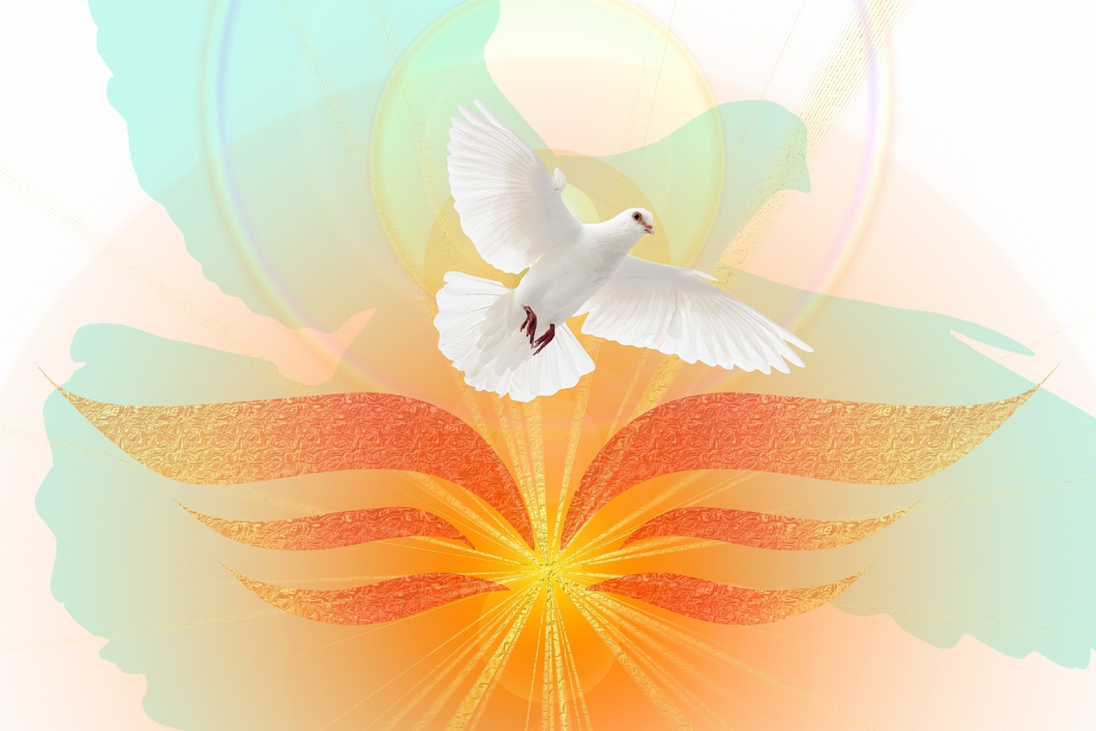

The Rev. Kirsten Snow Spalding, Rector
The Rev. Scott Gambrill Sinclair, Priest in Residence
The Rev. Lynn Robinett, Assisting Priest
The Rev. Rebecca Morehouse, Deacon

333 Ellen Dr.
San Rafael, CA
www.nativityonthehill.org
nativityonthehill@gmail.com
415-479-7023

The Word of God

Entrance Rite

Entrance Hymn

Opening Acclamation
The people standing, the Celebrant says
 | Blessed be God: Father, Son, and Holy Spirit.
People | And blessed be his kingdom, now and for ever. Amen.

Collect for Purity
We say together
Almighty God, to you all hearts are open, all desires known, and from you no secrets are hid: Cleanse the thoughts of our hearts by the inspiration of your Holy Spirit, that we may perfectly love you, and worthily magnify your holy Name; through Christ our Lord. Amen.

Opening Anthem

The Collect of the Day
The Celebrant says
 | The Lord be with you.
People  Celebrant | And also with you.  Let us pray
The Celebrant says the collect.

People | Amen

The Lessons

First Reading:
The people sit.
After each reading the Reader says:
The Word of the Lord
Peole Thanks be to God.
Silence may follow.

Psalm:
Remain seated.

Second Reading:
The people sit.
Reader The Word of the Lord
People Thanks be to God.
Silence may follow.

Sequence Hymn
All stand.

Gospel
All stand.
The Holy Gospel of our Lord Jesus Christ according to_________
People Glory to you, Lord Christ.
After the Gospel, the Reader says
The Gospel of the Lord.
People Praise to you, Lord Christ.

The Sermon

The Creed
All stand.
The Prayers of the People
All remain standing.
In peace, we pray to you, Lord God.
Silence
For all people in their daily life and work;
For our families, friends, and neighbors, and for those who are alone.
For this community, the nation, and the world;
For all who work for justice, freedom, and peace.
For the just and proper use of your creation;
For the victims of hunger, fear, injustice, and oppression.
For all who are in danger, sorrow, or any kind of trouble;
For those who minister to the sick, the friendless, and the needy.
For the peace and unity of the Church of God;
For all who proclaim the Gospel, and all who seek the Truth.
For Michael our Presiding Bishop, and Mark our Bishop; and for all bishops
and other ministers;
For all who serve God in his Church.
For the special needs and concerns of this congregation.
Silence
The People may add their own petitions
Hear us, Lord;
For your mercy is great.
We thank you, Lord, for all the blessings of this life.
Silence
The People may add their own thanksgivings
We will exalt you, O God our King;
And praise your Name for ever and ever.
We pray for all who have died, that they may have a place in your eternal kingdom.
Silence
The People may add their own petitions
Lord, let your loving-kindness be upon them;
Who put their trust in you.
We pray to you also for the forgiveness of our sins.
Silence may be kept.
Leader and People
Have mercy upon us, most merciful Father;
in your compassion forgive us our sins,
known and unknown,
things done and left undone;
and so uphold us by your Spirit
that we may live and serve you in newness of life,
to the honor and glory of your Name;
through Jesus Christ our Lord. Amen.
The Celebrant concludes with an absolution or a suitable Collect.

The Peace
All stand.
Celebrant | The peace of God be always with you.
People | And also with you.

Then the Ministers and the People may greet one another in the name of the Lord.

ANNOuNCEMENTS

The Holy Communion

Offertory Sentence
The Celebrant says
Walk in love, as Christ loved us and gave himself for us, an offering and sacrifice to God. Ephesians 5:2

Offertory Hymn

The Great Thanksgiving

Sursum Corda EOM1 11 Lift up your hearts Sursum corda (Hurd) Music for the Eucharist
The People remain standing.

Proper Preface
Presider
All thanks and praise
are yours at all times and in all places,
our true and loving God;
through Jesus Christ, your eternal Word,
the Wisdom from on high by whom you created all things.
You laid the foundations of the world
and enclosed the sea when it burst out from the womb;
You brought forth all creatures of the earth
and gave breath to humankind.
Wondrous are you, Holy One of Blessing,
all you create is a sign of hope for our journey;
And so as the morning stars sing your praises
we join the heavenly beings and all creation
as we shout with joy:

Sanctus S 124 Holy, holy, holy (Hurd)
Presider and People

Words of Institution
The Presider continues
Glory and honor are yours, Creator of all,
your Word has never been silent;
you called a people to yourself, as a light to the nations,
you delivered them from bondage
and led them to a land of promise.
Of your grace, you gave Jesus
to be human, to share our life,
to proclaim the coming of your holy reign
and give himself for us, a fragrant offering.
Through Jesus Christ our Redeemer,
you have freed us from sin,
brought us into your life,
reconciled us to you,
and restored us to the glory you intend for us.
We thank you that on the night before he died for us
Jesus took bread,
and when he had given thanks to you, he broke it,
gave it to his friends and said:
“Take, eat, this is my Body, broken for you.
Do this for the remembrance of me.”
After supper Jesus took the cup of wine,
said the blessing, gave it to his friends and said:
“Drink this, all of you:
this cup is the new Covenant in my Blood,
poured out for you and for all
for the forgiveness of sin.
Do this for the remembrance of me.”
And so, remembering all that was done for us:
the cross, the tomb, the resurrection and ascension,
longing for Christ’s coming in glory,
and presenting to you these gifts
your earth has formed and human hands have made,
we acclaim you, O Christ:
Presider and People
Dying, you destroyed our death.
Rising, you restored our life.
Christ Jesus, come in glory!

Epiclesis
The Presider continues
Send your Holy Spirit upon us
and upon these gifts of bread and wine
that they may be to us
the Body and Blood of your Christ.
Grant that we, burning with your Spirit’s power,
may be a people of hope, justice and love.
Giver of Life, draw us together in the Body of Christ,
and in the fullness of time gather us
with [blessed __________, and] all your people
into the joy of our true eternal home.
Through Christ and with Christ and in Christ,
by the inspiration of your Holy Spirit,
we worship you our God and Creator
in voices of unending praise.
Presider and People
Blessed are you now and for ever. AMEN.

The Lord’s Prayer
As our Savior Christ has taught us, we now pray,
People and Celebrant
Our Father in heaven,
hallowed be your Name,
your kingdom come,
your will be done, on earth as in heaven.
Give us today our daily bread.
Forgive us our sins
as we forgive those who sin against us.
Save us from the time of trial
and deliver us from evil.
For the kingdom, the power,
and the glory are yours,
now and forever. Amen.

The Breaking of the Bread

Fraction Anthem

Invitation
The Celebrant says
The Gifts of God for the People of God.

Distribution
The ministers receive the Sacrament in both kinds, and then immediately deliver it to the people.
The Bread and the Cup are given to the communicants with these words
The Body (Blood) of our Lord Jesus Christ keep you in everlasting life. [Amen.]

Communion Hymn

Post-Communion Prayer
After Communion, the Celebrant says
Let us pray.
Celebrant and People
Loving God,
we give you thanks
for restoring us in your image
and nourishing us with spiritual food
in the Sacrament of Christ’s Body and Blood.
Now send us forth
a people, forgiven, healed, renewed;
that we may proclaim your love to the world
and continue in the risen life of Christ our Savior. Amen.

BlessingS
We say together a blessing for all celebrating birthdays and anniversaries.
O God, our times are in your hand: Look with favor, we pray, on your servant N. as he begins another year. sGrant that he may grow in wisdom and grace, and strengthen his trust in your goodness all the days of his life; through Jesus Christ our Lord. Amen.

The Priest blesses the people, saying
Live without fear: your Creator has made you holy, has always protected you, and loves you as a mother. Go in peace to follow the good road and may God’s blessing be with you always. Amen.

Post-Communion Hymn

Dismissal
 | Let us go forth into the world, rejoicing in the power of the Spirit.
People | Thanks be to God.

From riteplanning.com.
Copyright © 2022 Church Publishing Inc. All rights reserved.

