Nativity Worships
Fifth Sunday of the Epiphany
Holy Eucharist Rite II

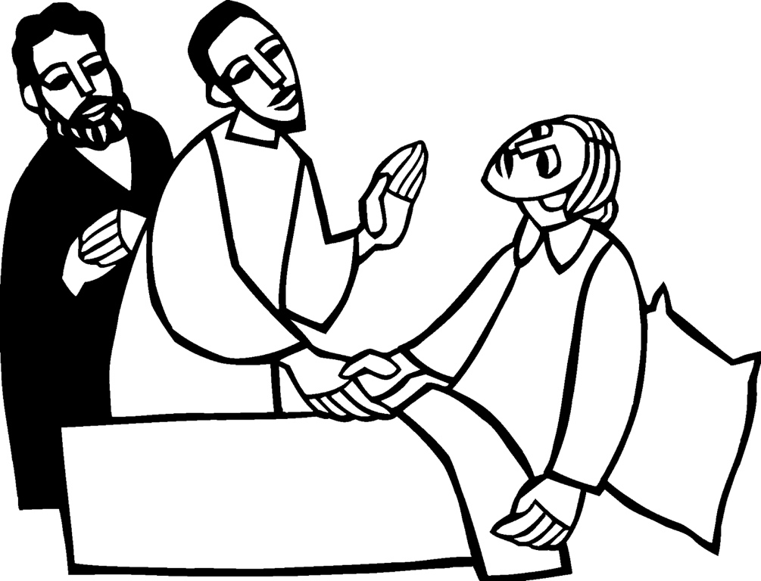

Sunday February 7, 2021
Facebook Livestream

Episcopal Church of the Nativity
San Rafael, California
The church on the hill in Lucas Valley

The Rev. Kirsten Snow Spalding, Rector
The Rev. Scott Sinclair, Assisting Priest
The Rev. Lynn Oldham Robinett, Assisting Priest
The Rev. Rebecca Morehouse, Deacon

The Word of God

Entrance Rite

Entrance Hymn Immortal, invisible, God only wise (St. Denio) (H 423)

Opening Acclamation (BCP p. 355)
The people standing, the Celebrant says
 | Blessed be God: Father, Son, and Holy Spirit.
People | And blessed be his kingdom, now and for ever. Amen.

Collect for Purity (BCP p. 355)
The Celebrant may say
Almighty God, to you all hearts are open, all desires known, and from you no secrets are hid: Cleanse the thoughts of our hearts by the inspiration of your Holy Spirit, that we may perfectly love you, and worthily magnify your holy Name; through Christ our Lord. Amen.

Opening Anthem or Song of Praise WLP 900 Glory to God (Canticle 20) (Rutter) (BCP p. 356)
The following is sung, all standing

The Collect of the Day (BCP p. 357)
Celebrant | God be with you.
People | And also with you.
Celebrant | Let us pray.

Set us free, O God, from the bondage of our sins, and give us the liberty of that abundant life which you have made known to us in your Son our Savior Jesus Christ; who lives and reigns with you, in the unity of the Holy Spirit, one God, now and for ever. Amen.

The Lessons

First Reading: Isaiah 40:21-31
The people sit.
A Reading from the book of the prophet Isaiah.
²¹Have you not known? Have you not heard?
Has it not been told you from the beginning?
Have you not understood from the foundations of the earth?
²²It is he who sits above the circle of the earth,
and its inhabitants are like grasshoppers;
who stretches out the heavens like a curtain,
and spreads them like a tent to live in;
²³who brings princes to naught,
and makes the rulers of the earth as nothing.
²⁴Scarcely are they planted, scarcely sown,
scarcely has their stem taken root in the earth,
when he blows upon them, and they wither,
and the tempest carries them off like stubble.
²⁵To whom then will you compare me,
or who is my equal? says the Holy One.
²⁶Lift up your eyes on high and see:
Who created these?
He who brings out their host and numbers them,
calling them all by name;
because he is great in strength,
mighty in power,
not one is missing.
²⁷Why do you say, O Jacob,
and speak, O Israel,
“My way is hidden from the Lord,
and my right is disregarded by my God”?
²⁸Have you not known? Have you not heard?
The Lord is the everlasting God,
the Creator of the ends of the earth.
He does not faint or grow weary;
his understanding is unsearchable.
²⁹He gives power to the faint,
and strengthens the powerless.
³⁰Even youths will faint and be weary,
and the young will fall exhausted;
³¹but those who wait for the Lord shall renew their strength,
they shall mount up with wings like eagles,
they shall run and not be weary,
they shall walk and not faint.

Reader | Hear what the Spirit is saying to God’s people.
People | Thanks be to God.

Silence may follow.

Psalm: Psalm 147:1-12, 21c
Remain seated.
¹Hallelujah!
How good it is to sing praises to our God! *
how pleasant it is to honor him with praise!
²The Lord rebuilds Jerusalem; *
he gathers the exiles of Israel.
³He heals the brokenhearted *
and binds up their wounds.
⁴He counts the number of the stars *
and calls them all by their names.
⁵Great is our Lord and mighty in power; *
there is no limit to his wisdom.
⁶The Lord lifts up the lowly, *
but casts the wicked to the ground.
⁷Sing to the Lord with thanksgiving; *
make music to our God upon the harp.
⁸He covers the heavens with clouds *
and prepares rain for the earth;
⁹He makes grass to grow upon the mountains *
and green plants to serve mankind.
¹⁰He provides food for flocks and herds *
and for the young ravens when they cry.
¹¹He is not impressed by the might of a horse; *
he has no pleasure in the strength of a man;
¹²But the Lord has pleasure in those who fear him, *
in those who await his gracious favor. ^{21c} Hallelujah!

Second Reading: 1 Corinthians 9:16-23
The people sit.
A Reading from Paul's First letter to the Church in Corinth.
¹⁶If I proclaim the gospel, this gives me no ground for boasting, for an obligation is laid on me, and woe to me if I do not proclaim the gospel! ¹⁷For if I do this of my own will, I have a reward; but if not of my own will, I am entrusted with a commission. ¹⁸What then is my reward? Just this: that in my proclamation I may make the gospel free of charge, so as not to make full use of my rights in the gospel.
¹⁹For though I am free with respect to all, I have made myself a slave to all, so that I might win more of them. ²⁰To the Jews I became as a Jew, in order to win Jews. To those under the law I became as one under the law (though I myself am not under the law) so that I might win those under the law. ²¹To those outside the law I became as one outside the law (though I am not free from God’s law but am under Christ’s law) so that I might win those outside the law. ²²To the weak I became weak, so that I might win the weak. I have become all things to all people, that I might by all means save some. ²³I do it all for the sake of the gospel, so that I may share in its blessings.

Reader | Hear what the Spirit is saying to God’s people.
People | Thanks be to God.

Silence may follow.

Sequence Hymn Heal me, hands of Jesus (Sharpe) (WLP 773)
All stand.
Gospel: Mark 1:29-39
All stand.
Deacon | The Holy Gospel of our Lord Jesus Christ according to Mark.
People | Glory to you, Lord Christ.

²⁹[When Jesus and the disciples] left the synagogue, they entered the house of Simon and Andrew, with James and John.³⁰Now Simon’s mother-in-law was in bed with a fever, and they told him about her at once. ³¹He came and took her by the hand and lifted her up. Then the fever left her, and she began to serve them.
³²That evening, at sunset, they brought to him all who were sick or possessed with demons. ³³And the whole city was gathered around the door. ³⁴And he cured many who were sick with various diseases, and cast out many demons; and he would not permit the demons to speak, because they knew him.
³⁵In the morning, while it was still very dark, he got up and went out to a deserted place, and there he prayed. ³⁶And Simon and his companions hunted for him. ³⁷When they found him, they said to him, “Everyone is searching for you.” ³⁸He answered, “Let us go on to the neighboring towns, so that I may proclaim the message there also; for that is what I came out to do.” ³⁹And he went throughout Galilee, proclaiming the message in their synagogues and casting out demons.

Deacon | The Gospel of our Savior.
People | Praise to you, Lord Christ.

The Sermon (BCP p. 358) The Rev. Kirsten Snow Spalding

The Creed (BCP p. 358)
All stand.
We believe in one God,
the Father, the Almighty,
maker of heaven and earth,
of all that is, seen and unseen.
We believe in one Lord, Jesus Christ,
the only Son of God,
eternally begotten of the Father,
God from God, Light from Light,
true God from true God,
begotten, not made,
of one Being with the Father.
Through him all things were made.
For us and for our salvation
he came down from heaven:
by the power of the Holy Spirit
he became incarnate from the Virgin Mary,
and was made man.
For our sake he was crucified under Pontius Pilate;
he suffered death and was buried.
On the third day he rose again
in accordance with the Scriptures;
he ascended into heaven
and is seated at the right hand of the Father.
He will come again in glory to judge the living and the dead,
and his kingdom will have no end.
We believe in the Holy Spirit, the Lord, the giver of life,
who proceeds from the Father and the Son.
With the Father and the Son he is worshiped and glorified.
He has spoken through the Prophets.
We believe in one holy catholic and apostolic Church.
We acknowledge one baptism for the forgiveness of sins.
We look for the resurrection of the dead,
and the life of the world to come. Amen.

The Prayers of the People (BCP p. 359)
All remain standing.
Let us pray for the Church and for the world.
Grant, Almighty God, that all who confess your Name may be united in your truth, live together in your love, and reveal your glory in the world.
Silence
Lord, in your mercy
Hear our prayer.
Guide the people of this land, and of all the nations, in the ways of justice and peace; that we may honor one another and serve the common good.
Silence
Lord, in your mercy
Hear our prayer.
Give us all a reverence for the earth as your own creation, that we may use its resources rightly in the service of others and to your honor and glory.
Silence
Lord, in your mercy
Hear our prayer.
Bless all whose lives are closely linked with ours, We pray for healing for our parish members, Carissa, Marge, Juliette, Mary, Dan, Donna, Jim, Leslie, and Duane. And for our families, friends and neighbors remembering especially Colton, Ellen, Katherine, Ed, Daniel, Marco, John, Thomas, Marg, Mary O, Mary P, Jill, Doug, Barbara, Nathaniel, Les, Polly, Linda, Sara, Kelly and Dennis, Bob C, Jason, Kathy P, and Myles Miller and his family and grant that we may serve Christ in them, and love one another as he loves us.
Silence
Lord, in your mercy
Hear our prayer.
Comfort and heal all those who suffer in body, mind, or spirit; We remember especially those suffering COVID 19 and all who are caring for them, those whose relationships are broken, those who live in fear and despair; give them courage and hope in their troubles, and bring them the joy of your salvation.
Silence
Lord, in your mercy
Hear our prayer.
We commend to your mercy all who have died, that your will for them may be fulfilled; and we pray that we may share with all your saints in your eternal kingdom.
Silence
Lord, in your mercy
Hear our prayer.
The Celebrant adds a concluding Collect.
Hasten, O God, the coming of your kingdom; and grant that we your servants, who now live by faith, may with joy behold Jesus Christ, our only Mediator and Advocate at his coming in glorious majesty. Amen.

Confession of Sin (BCP p. 359)

The Deacon or Celebrant says
Let us confess our sins to God.
Silence may be kept.
Minister and People
Most merciful God,
we confess that we have sinned against you
in thought, word, and deed,
by what we have done,
and by what we have left undone.
We have not loved you with our whole heart;
we have not loved our neighbors as ourselves.
We are truly sorry and we humbly repent.
For the sake of your Son Jesus Christ,
have mercy on us and forgive us;
that we may delight in your will,
and walk in your ways,
to the glory of your Name. Amen.
The Priest stands and says
Almighty God have mercy on you, forgive you all your sins through our Lord Jesus Christ, strengthen you in all goodness, and by the power of the Holy Spirit keep you in eternal life. Amen.

The Peace (BCP p. 360)
All stand.
Celebrant | The peace of the Lord be always with you.
People | And also with you.

Then the Ministers and the People may greet one another in the name of the Lord.
Announcements

We had a wonderful Annual Meeting last week. We welcomed new Vestry Members Penny Poteet, Jean Heine, Carl Robinett and Norma Barr and we approved our annual budget. Annual Reports are available on our website at nativityonthehill.org and a recording of the meeting is there too.

Bible Study Group is now reading: The Universal Christ: How a Forgotten Reality Can Change Everything We See, Hope For and Believe, by Richard Rohr. The group meets on Thursdays at 10:30 a.m., via Zoom.

Join a Christian Small Group for Lent (and maybe beyond!) See the details in Nativity Notes Online. Or, just go to this link, to fill out a very brief survey. We will do our best to find you a group that meets your growing spiritual needs and hopes.

There will be a Zoom Coffee Hour following our service this morning. The link is here or on our
website.

We will with thanksgiving receive offerings of Nativity pledges and plate today. You can contribute by sending a check to the church or by using the “Give” button on our website,www.nativityonthehill.org.

All who participate in this Holy Eucharist virtually receive the full benefits of the sacrament by coming with the intention of being united with Christ and one another. (BCP 457)

The Holy Communion

Offertory Sentence (BCP p. 376)
The Celebrant says
Through Christ let us continually offer to God the sacrifice of praise, that is, the fruit of lips that acknowledge his Name. But do not neglect to do good and to share what you have, for such sacrifices are pleasing to God. Hebrews 13:15, 16

Offertory Hymn Surely it is God who saves me (Thomas Merton) (H 679)

The Great Thanksgiving

Sursum Corda
The People remain standing.
Celebrant | The Lord be with you.
People | And also with you.
Celebrant | Lift up your hearts.
People | We lift them to the Lord.
Celebrant | Let us give thanks to the Lord our God.
People | It is right to give our thanks and praise.

Proper Preface
Celebrant
We praise you and we bless you, holy and gracious God,
source of life abundant.
From before time you made ready the creation.
Your Spirit moved over the deep
and brought all things into being:
sun, moon, and stars;
earth, winds, and waters;
and every living thing.
You made us in your image,
and taught us to walk in your ways.
But we rebelled against you, and wandered far away;
and yet, as a mother cares for her children,
you would not forget us.
Time and again you called us
to live in the fullness of your love.
And so this day we join with Saints and Angels
in the chorus of praise that rings through eternity,
lifting our voices to magnify you as we sing (say):

Sanctus
Celebrant and People
Holy, holy, holy Lord, God of power and might,
heaven and earth are full of your glory.
Hosanna in the highest.
Blessed is the one who comes in the name of the Lord.
Hosanna in the highest.

Words of Institution
The Celebrant continues
Glory and honor and praise to you, holy and living God.
To deliver us from the power of sin and death
and to reveal the riches of your grace,
you looked with favor upon Mary, your willing servant,
that she might conceive and bear a son,
Jesus the holy child of God.
Living among us, Jesus loved us.
He broke bread with outcasts and sinners,
healed the sick, and proclaimed good news to the poor.
He yearned to draw all the world to himself
yet we were heedless of his call to walk in love.
Then, the time came for him to complete upon the cross
the sacrifice of his life,
and to be glorified by you.
On the night before he died for us,
Jesus was at table with his friends.
He took bread, gave thanks to you,
broke it, and gave it to them, and said:
“Take, eat:
This is my Body, which is given for you.
Do this for the remembrance of me.”
As supper was ending, Jesus took the cup of wine.
Again, he gave thanks to you,
gave it to them, and said:
“Drink this, all of you:
This is my Blood of the new Covenant,
which is poured out for you and for all
for the forgiveness of sins.
Whenever you drink it,
do this for the remembrance of me.”

Epiclesis
Now gathered at your table, O God of all creation,
and remembering Christ, crucified and risen,
who was and is and is to come,
we offer to you our gifts of bread and wine,
and ourselves, a living sacrifice.
Pour out your Spirit upon these gifts
that they may be the Body and Blood of Christ.
Breathe your Spirit over the whole earth
and make us your new creation,
the Body of Christ given for the world you have made.
In the fullness of time bring us,
with all your saints,
from every tribe and language and people and nation,
to feast at the banquet prepared
from the foundation of the world.
Through Christ and with Christ and in Christ,
in the unity of the Holy Spirit,
to you be honor, glory, and praise,
for ever and ever. AMEN

The Lord’s Prayer (BCP p. 363)
As our Savior Christ has taught us, we now pray,
People and Celebrant
Our Father in heaven,
hallowed be your Name,
your kingdom come,
your will be done, on earth as in heaven.
Give us today our daily bread.
Forgive us our sins
as we forgive those who sin against us.
Save us from the time of trial
and deliver us from evil.
For the kingdom, the power,
and the glory are yours,
now and forever. Amen.

The Breaking of the Bread

Fraction Anthem (BCP p. 364)
Alleluia. Christ our Passover is sacrificed for us;
Therefore let us keep the feast. Alleluia.

Invitation (BCP p. 364)
The Celebrant says
The Gifts of God for the People of God.

Distribution (BCP p. 365)
The ministers receive the Sacrament in both kinds, and then immediately deliver it to the people.
The Bread and the Cup are given to the communicants with these words
The Body of Christ, the bread of heaven. [Amen.]
The Blood of Christ, the cup of salvation. [Amen.]

Post-Communion Prayer (BCP p. 365)
After Communion, the Celebrant says
Let us pray.
Celebrant and People
Eternal God, heavenly Father,
you have graciously accepted us as living members
of your Son our Savior Jesus Christ,
and you have fed us with spiritual food
in the Sacrament of his Body and Blood.
Send us now into the world in peace,
and grant us strength and courage
to love and serve you
with gladness and singleness of heart;
through Christ our Lord. Amen.

BIRTHDAY AND ANNIVERSARY BLESSING
O God, our times are in your hand: Look with favor, we pray, on your servant N. as he begins another year. Grant that he may grow in wisdom and grace, and strengthen his trust in your goodness all the days of his life; through Jesus Christ our Lord. Amen.

Blessing (BCP p. 366)
The Priest blesses the people, saying
May the blessing of the God of Abraham and Sarah, and of Jesus Christ born of our sister Mary, and of the Holy Spirit, who broods over the world as a mother over her children, be upon you and remain with you always. Amen.

Post-Communion Hymn In Christ there is no East or West (McKee) (H 529)

In Christ there is no East or West,
In Him no South or North;
But one great fellowship of love
Throughout the whole wide earth.
In Him shall true hearts everywhere
Their high communion find;
His service is the golden cord,
Close binding humankind.
Join hands, then, members of the faith,
Whatever your race may be!
Who serves my Father as His child
Is surely kin to me.
In Christ now meet both East and West,
In Him meet North and South;
All Christly souls are one in Him
Throughout the whole wide earth.

Dismissal (BCP p. 366)
 | Let us bless the Lord.
People | Thanks be to God.

From riteplanning.com.
Copyright © 2021 Church Publishing Inc. All rights reserved.

